**Kaltura Quick Start Guide**

* **Content Management** (Content Tab)
* **Content Distribution** (Content Tab)
* **Content Syndication & SEO** (Content Tab)
* **Live Streaming**(Content Tab)
* **Video Delivery Settings** (Settings Tab)
* **Mobile Delivery** (Settings Tab)
* **Access Control Settings** (Settings Tab)
* **Custom Metadata** (Settings Tab)
* **Advertising** (Studio Tab)
* **Player Design** (Studio Tab)
* **Users, Roles and Permissions** (Administration Tab)

**Content Management**

* **Logging into the Kaltura Management Console (KMC)**
* **Uploading videos from your desktop to your website**
  + Upload videos to the KMC
  + Embed videos on your site
* **Creating and embedding a playlist on your website**
  + Manual Playlist
  + Rules Based Playlist
  + Embed a playlist on your site
* **Creating and managing content categories**
* **Migrating content from your existing hosting / video service**

**Logging into the Kaltura Management Console (KMC)**

Go to the Kaltura Management Console (KMC) at: <http://www.kaltura.com/index.php/kmc>  
and log-in with the credentials that you received in the “Kaltura Registration Confirmation” email.

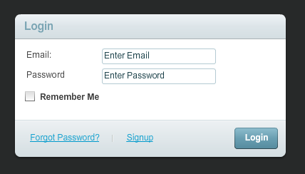

**Uploading videos from your desktop to your website**

**Upload videos to the KMC**

1. Go to the Content tab>Upload section.
2. Select the Transcoding Profile to use in this upload session using the drop-down menu
3. Click the Upload button to launch the Media Uploader.

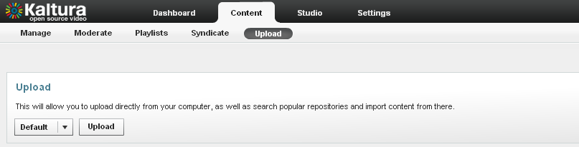

1. In the Media Uploader, click the browse button to select videos from your desktop. Hold down the CTRL key to select multiple files.

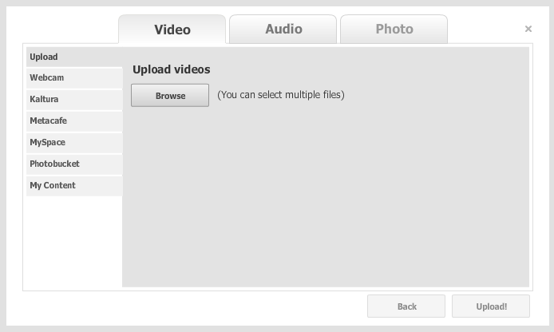

1. Click the upload button to start the file transfer  
     
   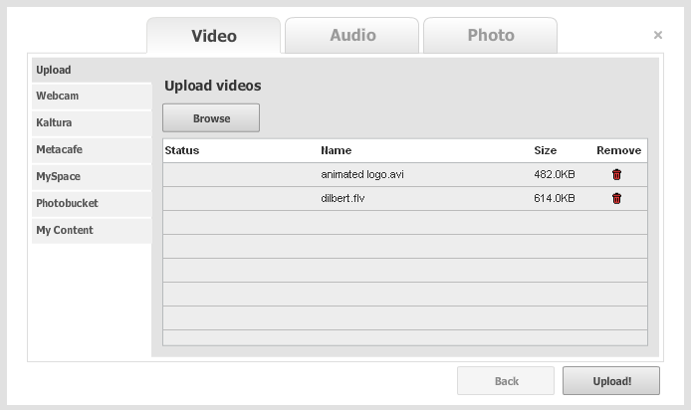
2. Add titles and tags to your videos.  
     
   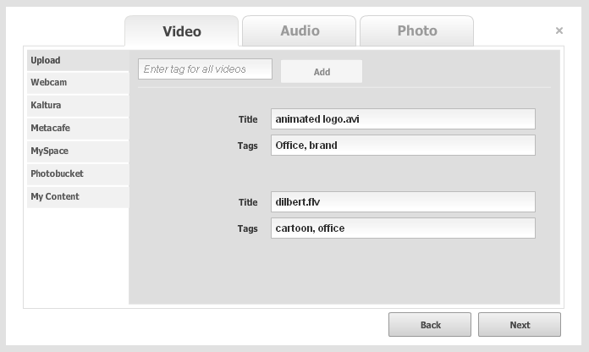
3. After the system completes the file conversions you will be able to see your uploads and their status in the Manage tab.

**Embed videos on your site**

1. In the Manage tab, locate the files that you want to place on your website and click on Preview & Embed

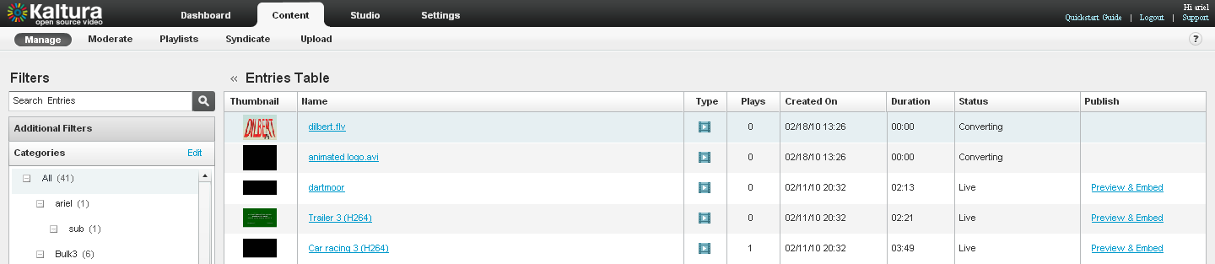

1. Select your preferred player skin from the drop down menu and grab the embed code. To learn more about embedding videos for mobile devices go to the mobile delivery section.

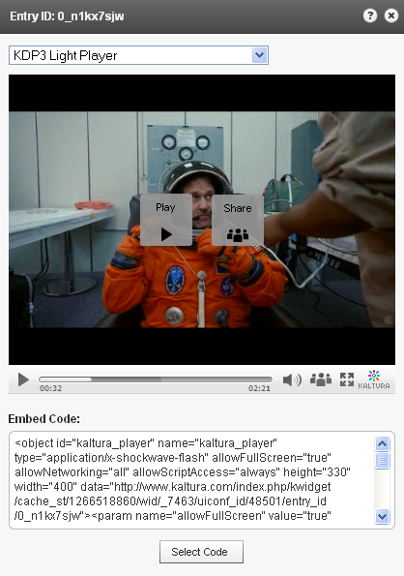

1. Add the embed code to your website HTML source and you're done

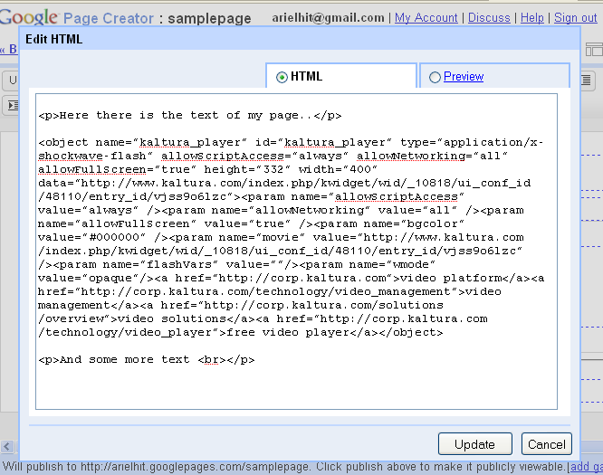

**Creating Playlists and embedding them on your website**

A playlist is a list of media items (videos, audios, images) that can be embedded with a player in your website. Manual playlists allow you to select a static list of items, while rules based playlists allow you to define a dynamic list.

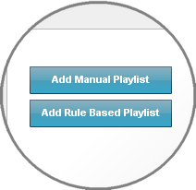Go to theContent tab>Playlist section and select either a Manual Playlist or a Rule Based Playlist   
  
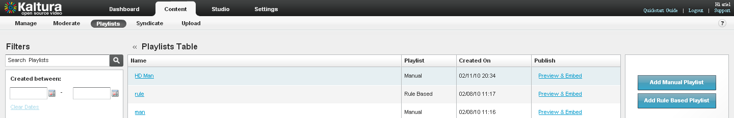

**Creating a Manual Playlist**

1. Enter a name for your playlist (required) and select Manual in the Type field.
2. Using the Filters search for the entries you’d like to include - the results will appear in the Entries Table.
3. Add entries to your playlist by clicking the desired entry followed by the Add or Remove buttons.
4. Click "Save" to complete the process.

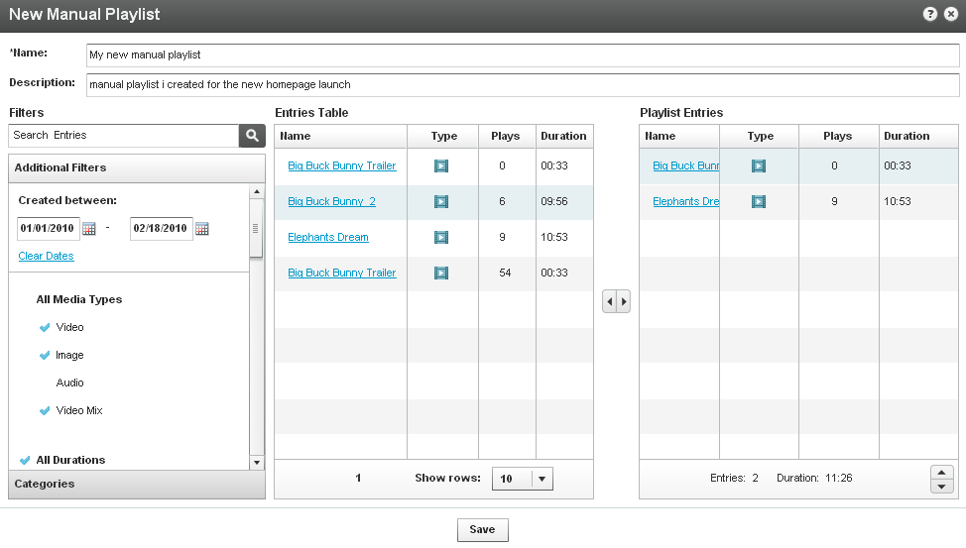

Change order of entries

Add to Playlist

Remove from Playlist

**Creating a Rules Based Playlist**

A rules based playlist is a dynamic playlist that is automatically updated when content is uploaded or edited. For example you can create a “Most Viewed” playlist, a “Most Recent” playlist, as well as a playlist based on single or multiple filters, such as “videos tagged with “dogs” and created during January 2010”.

Your playlist can be based on a single rule or multiple rules:

**Single Rule Playlist**

1. Enter a name for your playlist (required).
2. Using the Filters search for the entries you’d like to include - the results will appear in the Entries Table.

Note: You can choose more than one type of filter (for instance, text search + date + media type), the logical relationship between fields will be an "AND" relationship.

1. Select your preferred video order from the Order By drop down menu
2. Select the total number of entries you’d like to include in the playlist via the Limit Playlist result box.
3. Click “Save Changes” to complete the process.

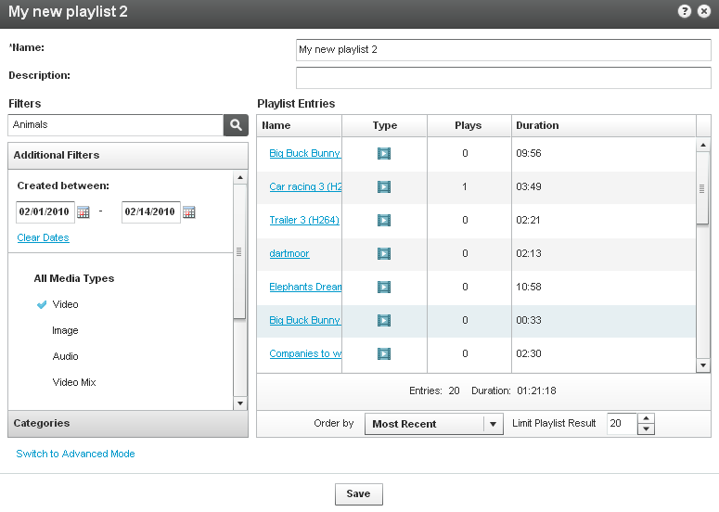

**Multiple Rule Playlist - Advanced Mode**

Advanced Mode enables you to create playlists based on multiple rules.

1. Click Switch to Advanced Mode.
2. Enter a name for your playlist (required).
3. Click Add Rule to create a new playlist rule (see Single Rule Playlist to learn about creating rules)
4. Add any number of additional rules. Use the Remove Rule and Edit Rule buttons to make changes to your list of rules.
5. Rules will be applied to the playlist in the order they appear, so use the arrows to change the order of the rules

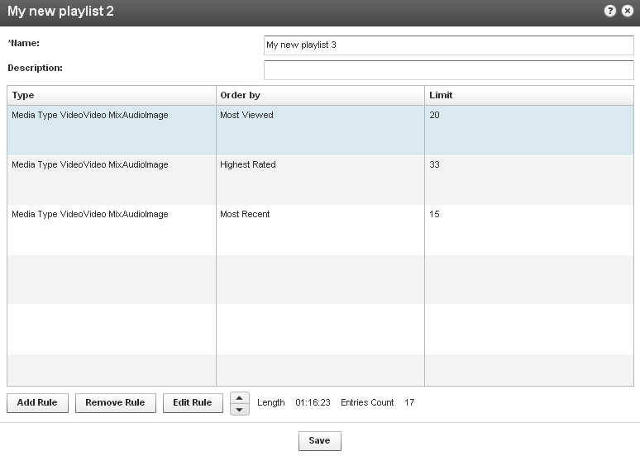

Change the order of the rules

**Embedding a Playlist on your site**

1. Go to the Content tab>Playlists section and locate the playlist that you want to place on your website. Click on Preview & Embed.

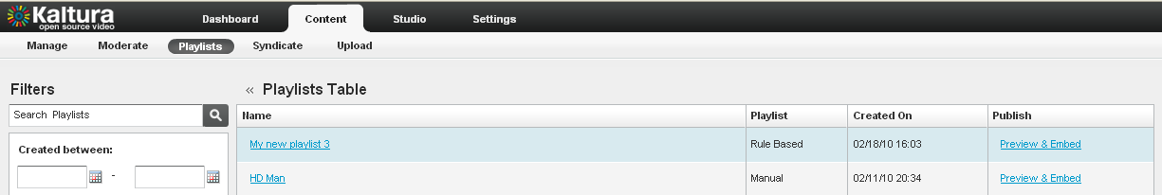

1. Select your preferred playlist skin from the drop down menu and grab the embed code.

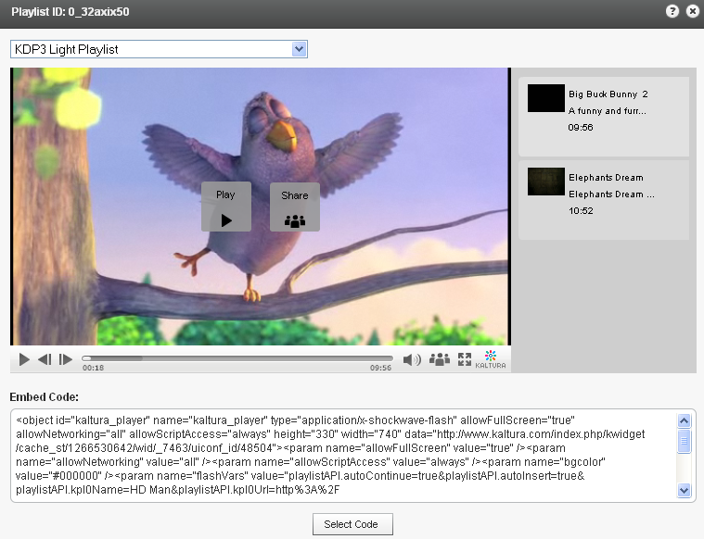

1. Add the embed code to your website HTML source.

**Creating and Managing Content Categories**

Media entries are divided into categories. The different categories are built in a tree-like hierarchy where each category can include multiple sub-categories.

1. To add a content category click Edit on the top left corner of the Filter bar.

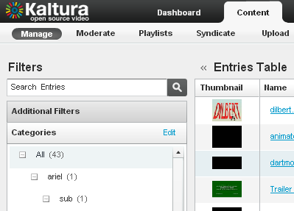

1. Add or remove categories by clicking on the “+ / -” icons that appear when you hover with your mouse over a specific category.

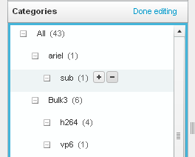 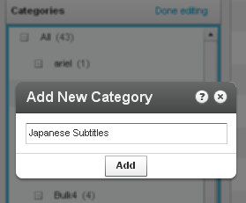

1. To change the tree location of any category just drag-and-drop categories from one location to another.
2. To assign a media entry to a specific category, just drag-and-drop the entry from the entries table on the right to the desired category on the left.

**Migrating content from your existing hosting / video service – Bulk Upload Process**

1. Go to the Content tab>Upload section>Import from Existing Host
2. Download the sample CSV file – the file contains examples of how to add the URLs and metadata of your existing content. Replace the sample data with your own.

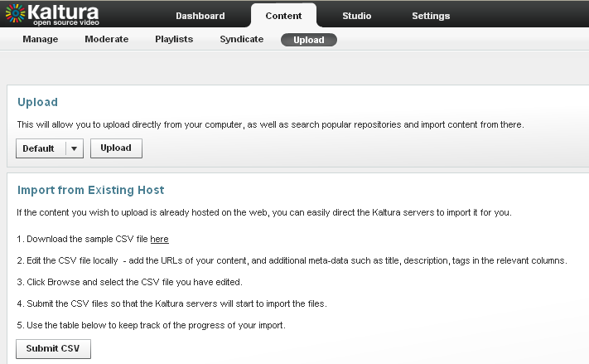

1. Click Submit CSV to upload the modified file.
2. The process is complete once the status in the table is Finished.

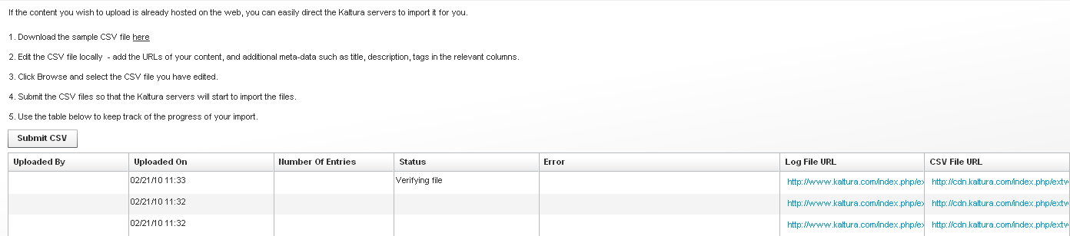

5. The videos will now appear in the Entries table in the KMC Content tab > Manage section.

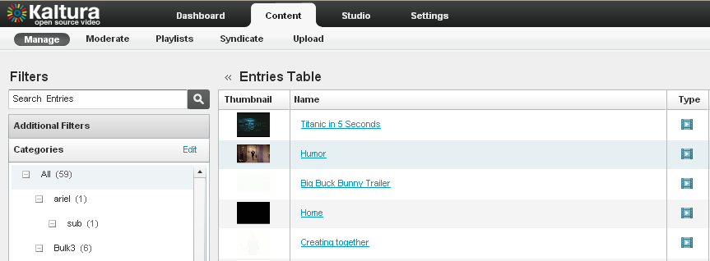

**Content Distribution**

* **Distributing content**
  + **Adding a distributor for a video package**
  + **Scheduling a video package**
  + **Validating a video package**
    - Missing Flavor Error
    - Metadata Error
    - Missing Thumbnail Error
  + **Filtering distributed content**
  + **Removing a distributor from a video package**

**Distributing content**

You can create and automate customized video packages to send to distribution partners, such as YouTube, Hulu, Comcast, MySpace, and MSN.

You define the destinations for each video package.

For each distribution destination, you control aspects such as the video qualities, number and size of thumbnails, metadata, and scheduling data.

**Adding a distributor for a video package**

Note: To enable automatic distribution of **all** new entries, [contact us](http://corp.kaltura.com/about/contact) or call +1-800-871-5224.

1. Go to the “Content” tab and select “Manage” from the menu.
2. In the Entries Table, click the name of the entry that you want to distribute.
3. In the "Edit Entry" window, go to the "Distribution" tab and click "Add / Remove Distributors".

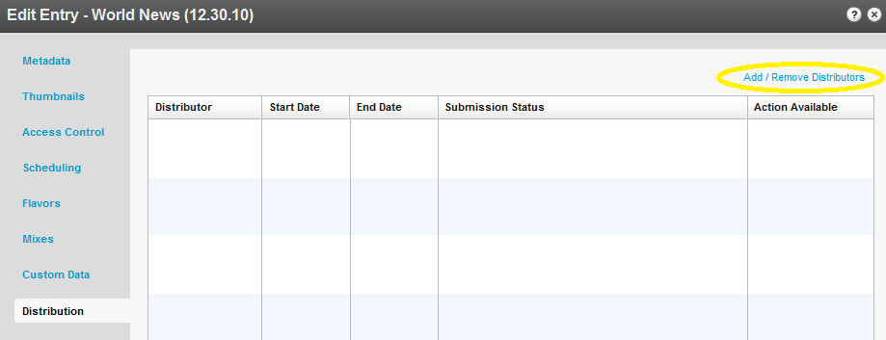

1. In the "Add / Remove Distributors" window, check the distributors you want for the entry.

To distribute an entry as soon as it is ready, check the "Distribute Automatically" column.

To select or clear all items in a column, click "All" or "None" at the top of the column.

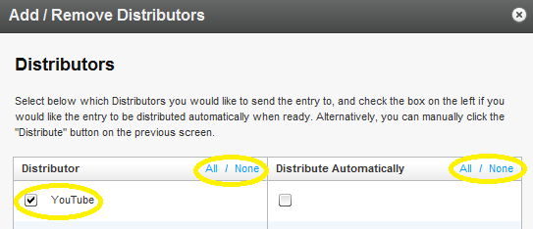

Click "Apply" to save your changes and return to the "Distribution" tab.

1. Click “Save Changes” to complete the process.

**Scheduling a video package**

To schedule when an entry is available for each distributor:

1. Go to the “Content” tab and select “Manage” from the menu.
2. In the Entries Table, click the name of the entry that you want to schedule.
3. In the "Edit Entry" window, go to the "Distribution" tab and click the name of a distributor.

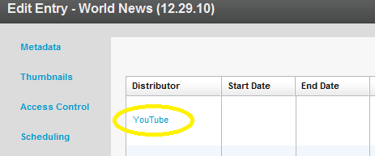

1. In the "Distribution Details" window, set the start and end dates and times, and click "Save" to return to the "Distribution" tab.

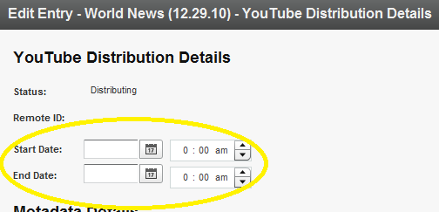

1. Click “Save Changes” to complete the process.

**Validating a video package**

Errors may occur when you specify a video package distributor.

To find and resolve errors:

1. Go to the “Content” tab and select “Manage” from the menu.
2. In the Entries Table, click the name of an entry for which you added a distributor.
3. In the "Edit Entry" window, go to the "Distribution" tab and click the error name in the "Submission Status" column to display a description of the error.

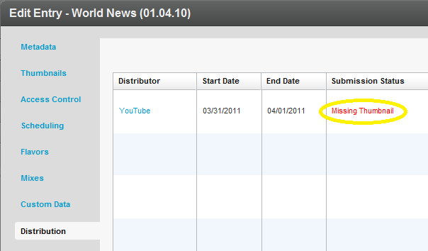

* + You also can click the name of a distributor in the "Distribution" tab, and then click the error name in the "Distribution Details" window.

1. Follow the instructions in the error description.

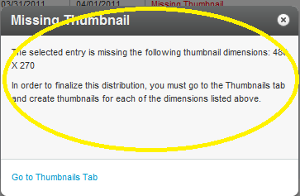

The following errors may occur:

Missing Flavor Error

To add a flavor:

Note: If you click "Go to Flavors Tab" in the error description, skip to step 4.

1. Go to the “Content” tab and select “Manage” from the menu.
2. In the Entries Table, click the name of the entry that is missing a flavor.
3. In the "Edit Entry" window, go to the "Flavors" tab.
4. Click "Convert" or "Reconvert" for each transcoding flavor specified in the error description, and click "Save Changes".

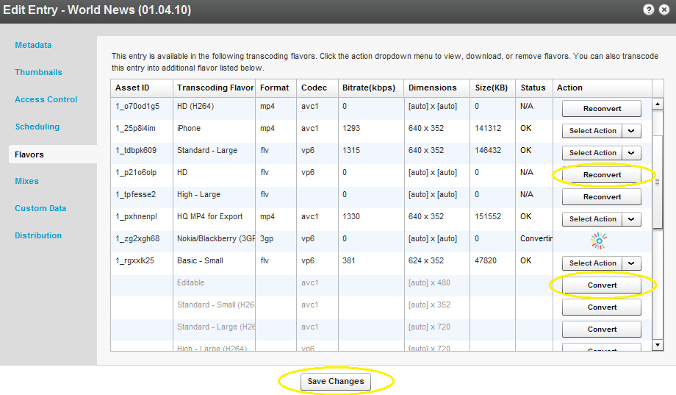

Metadata Error

To correct metadata:

Note: If you click "Go to Metadata Tab" in the error description, skip to step 4.

1. Go to the “Content” tab and select “Manage” from the menu.
2. In the Entries Table, click the name of the entry that has a metadata error.
3. In the "Edit Entry" window, go to the "Metadata" tab.
4. Add the missing information in the metadata field specified in the error description, and click "Save Changes".
5. If the submission status error still is displayed in the "Edit Entry" window's "Distribution" tab:
   1. In the "Edit Entry" window, go to the "Custom Data" tab.
   2. Add the missing information specified in the error description, and click "Save Changes".

Missing Thumbnail Error

To add a thumbnail:

Note: If you click "Go to Thumbnails Tab" in the error description, skip to step 4.

1. Go to the “Content” tab and select “Manage” from the menu.
2. In the Entries Table, click the name of the entry that is missing a thumbnail.
3. In the "Edit Entry" window, go to the "Thumbnails" tab.
4. Click "Add Thumbnail" and select "Grab from Video".

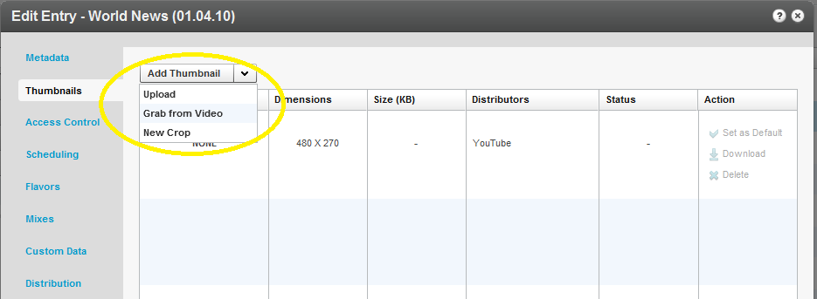

* + If you have a thumbnail file, select "Upload", specify the file location and name, and click "Open".

1. Play the video, pause on the frame you want, and click the thumbnail capture button.

A thumbnail will be captured from the highest quality video flavor.

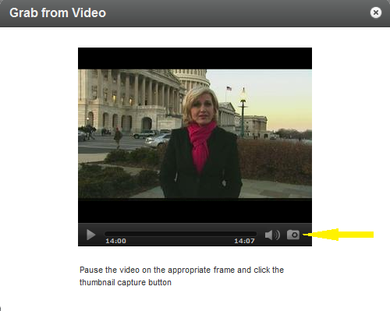

1. Exit to return to the "Thumbnails" window.

To modify the thumbnail dimensions:

1. In the "Edit Entry" window, click "Add Thumbnail" and‎ select "New Crop".
2. Select the thumbnail to modify.
3. Check the "Lock aspect ratio and scale to" option and select the values specified in the error description.
4. Adjust the display area with the handles on the image.
5. Click "Generate Thumbnail", and exit to return to the "Thumbnails" window.

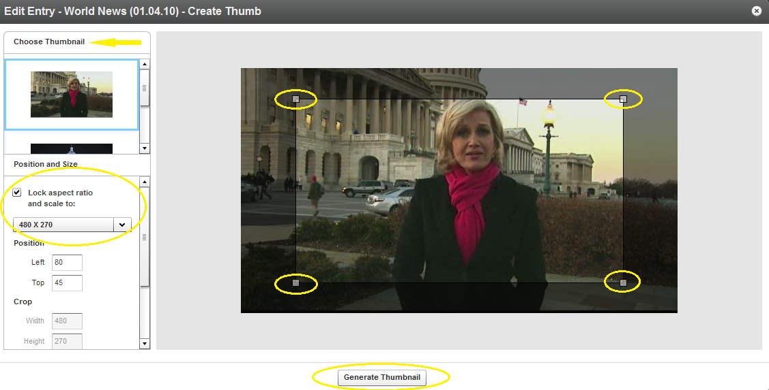

1. Click “Save Changes” to complete the process.

**Filtering distributed content**

To display only distributed content in the Entries Table:

1. Go to the “Content” tab and select “Manage” from the menu.
2. Select the "Distribution" filter and click a destination you want to display.

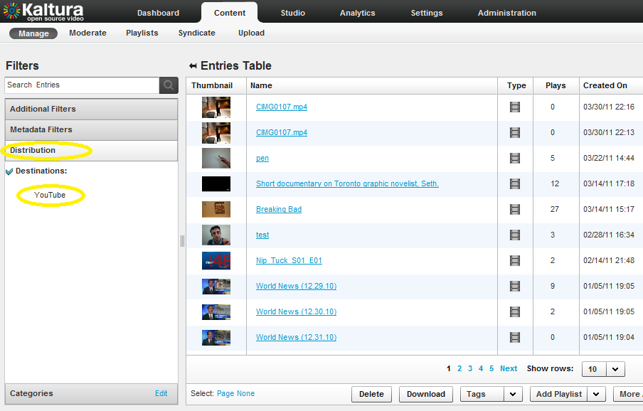

Only entries that are active for the selected destination are displayed in the Entries Table.

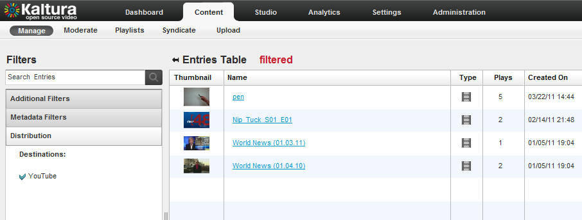

Note: To clear the filter, click the destination name in the Distribution filter again.

**Removing a distributor from a video package**

1. Go to the “Content” tab and select “Manage” from the menu.
2. In the Entries Table, click the name of the entry with a distributor that you want to remove.
3. In the "Edit Entry" window, go to the "Distribution" tab and click "Add / Remove Distributors".

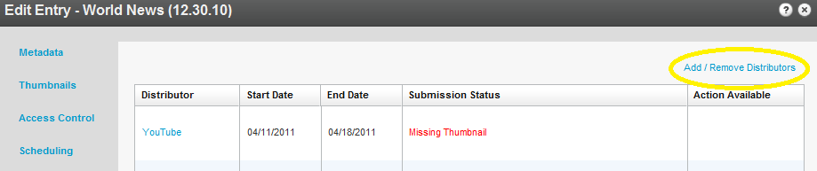

1. In the "Add / Remove Distributors" window, clear a distributor checkbox.

To clear all items in a column, click "None" at the top of the column.

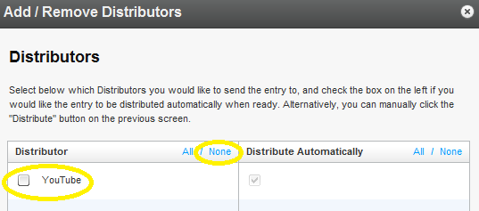

Click "Apply" to save your changes and return to the "Distribution" tab.

1. Click “Save Changes” to complete the process.

**Content Syndication & SEO**

* **Content Syndication**
  + **TubeMogul**
  + **iTunes**
* **SEO**
  + **Google**
  + **Yahoo!**

**Content Syndication**

Kaltura allows you to create video feeds in multiple formats that are ready for submission to 3rd party platforms.

**TubeMogul**

This premium syndication service enables you to distribute your content to over 20 video portals including YouTube, Dailymotion, Metacafe, etc.  
**Note:** requires a Kaltura-TubeMogul premium account ([contact us](http://corp.kaltura.com/about/contact) to learn more)

1. Go to the Content tab>Syndicate section and click Create New Feed.

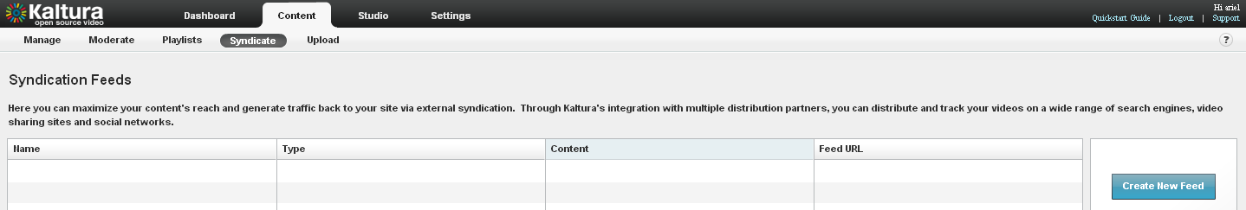

1. Enter the feed name (required), select TubeMogul from the Feed Type drop down, enter the TubeMogul Parameters and click Add Feed

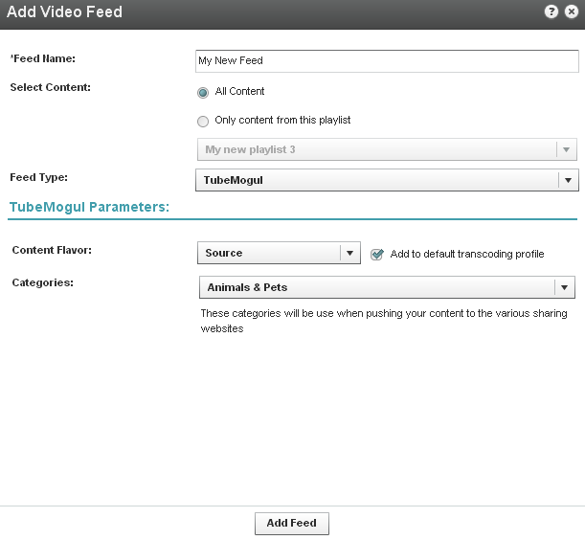

1. Copy the Feed URL

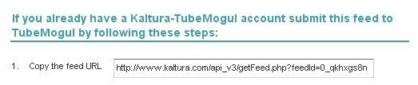

1. Login to your [Kaltura–TubeMogul account](http://www.tubemogul.com/auth/login?source=kaltura) and go to Advanced Tools> More Tools > select “MRSS Feed Manager” > Submit your feed

**iTunes**

This feed allows you to submit your content to the iTunes Store as a podcast.

1. Go to the Content tab> Syndicate section and click Create New Feed.
2. Enter the feed name (required), select iTunes from the Feed Type drop down, enter the iTunes Parameters and click Add Feed
3. To test the feed before submitting to the iTunes Store:
4. copy the URL
5. Launch the iTunes application installed on your desktop
6. Go to Advance > Subscribe to podcast and submit the feed URL
7. To **submit this feed** to the iTunes Store as a podcast/ video podcast:  
   Note that you will need an active Apple ID and the iTunes application installed
8. Copy the feed URL
9. Go to <https://phobos.apple.com/WebObjects/MZFinance.woa/wa/publishPodcast>(launches iTunes application in the right page)
10. Submit your feed

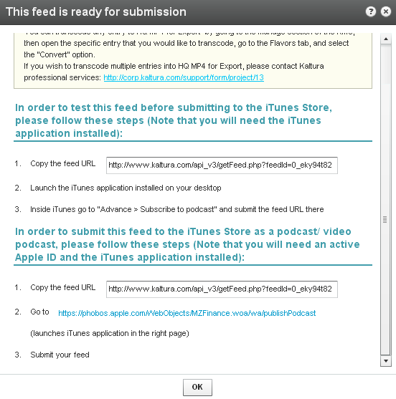

Submit Feed

Test Feed

**SEO**

Submitting feeds to major search engines helps to increase your content’s SEO, and ultimately direct more traffic to your website.

**Google**

1. Go to the Content tab>Syndicate section and click Create New Feed.
2. Enter the feed name (required), select Google from the Feed Type drop down, enter the Google Parameters and click Add Feed

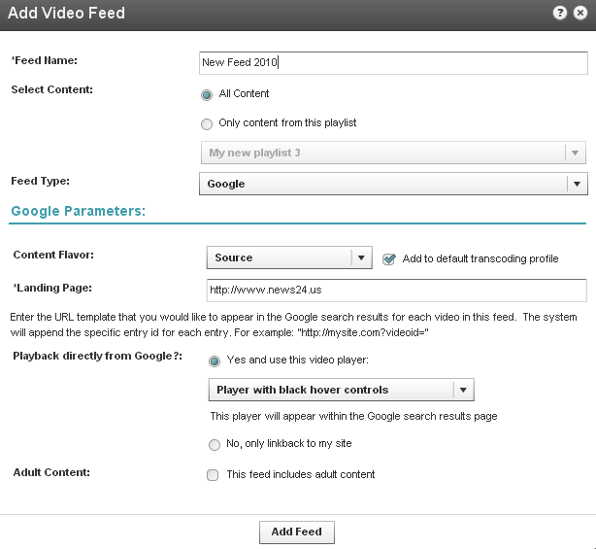

1. Submission of video feeds to Google is free of charge, yet requires some technical knowledge. It is recommended that your website’s webmaster be available for assistance.

Here are the technical guidelines for submission:

1. Google Webmaster Tool Setup

* Setup a Google Webmaster account for your website: <https://www.google.com/webmasters/tools/home>
* Setup your website in the Google Webmaster Tool –   
  follow the directions here: <http://www.google.com/support/webmasters/bin/answer.py?hl=en&answer=34592>  
  Make sure your site is valid based on the Google instructions.

1. Feed submission

* Create a server page on your website that redirects to this feed URL  
  For example, for a php implementation save a php file named redirect.php with the following content (replace the XXXXX with your feed URL)  
  <?php

Header( "HTTP/1.1 301 Moved Permanently" );

Header( "Location : XXXX”);

?>

* Login to the Google Webmaster Tool <https://www.google.com/webmasters/tools/home>
* Within the Google Webmaster Tool go to   
  “Site configuration > Sitemaps > Submit a sitemap”
* Submit the feed as your redirect page in your site, for example  <http://mysite.com/redirect.php>

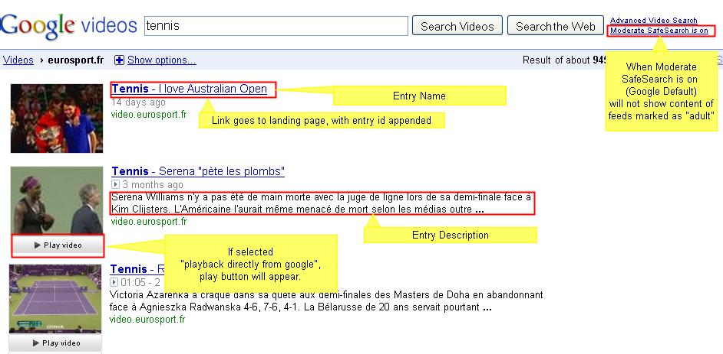

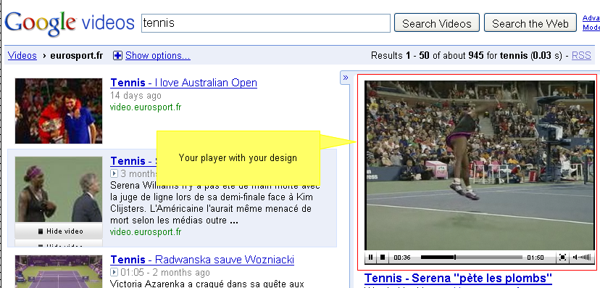

**Yahoo!**

1. Go to the Content tab> Syndicate section and click Create New Feed.
2. Enter the feed name (required), select Yahoo! from the Feed Type drop down, enter the Yahoo Parameters and click Add Feed

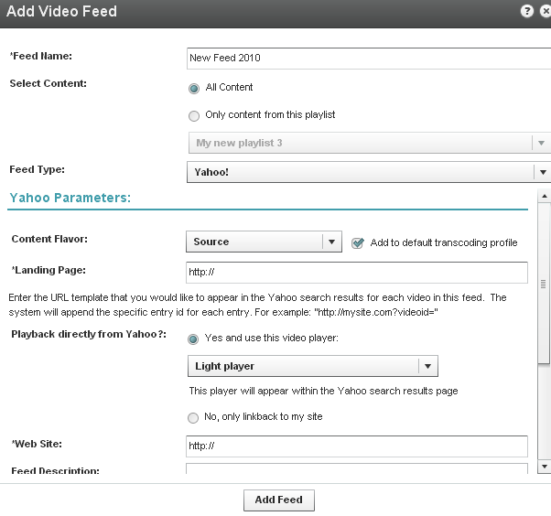

1. Copy the feed URL
2. Go to <http://video.search.yahoo.com/mrss/submit>
3. Fill in the form and submit your feed as a “Full feed”

**Live Streaming**

* **Basic setup**
  + **HW &SW setup**
  + **Set up a stream in the KMC**
  + **Broadcasting setup**
  + **Viewing setup**
* **Advanced configuration options**

**Kaltura’s Live Streaming is a paid service. To enable live streaming for your account** [**contact us**](http://corp.kaltura.com/about/contact)

**or call +1-800-871-5224**

Once your account has been enabled, follow the steps below to set up Kaltura’s Live Streaming service.

**Basic setup**

**HW & SW setup**

1. Download Flash Media Encoder (FME) from: <http://www.adobe.com/products/flashmediaserver/flashmediaencoder/>
2. Install FME on your local Windows machine (follow the FME installation guide and minimum requirements described in Appendix A of this document)
3. Connect your camera to the installed computer

**Set up a stream in the KMC**

1. Login into the Kaltura Management Console, navigate to the Content/ Manage tab and click on the “New Live Stream” button.

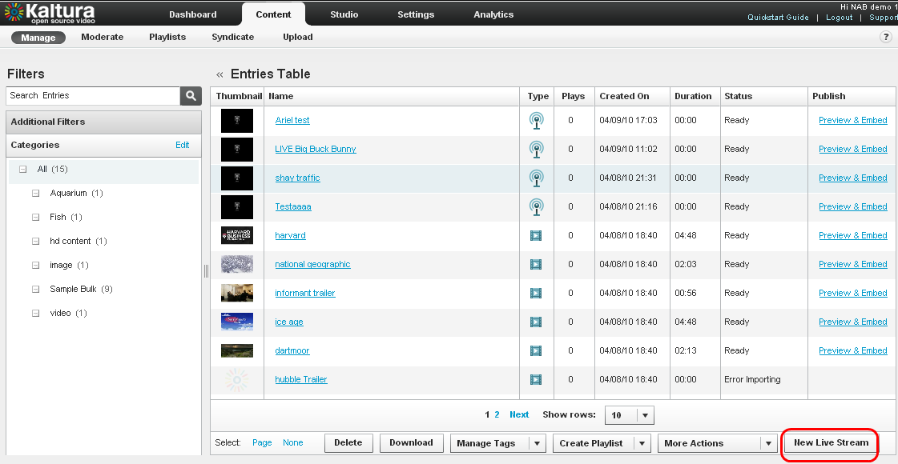

2. Fill in the form with the following details:

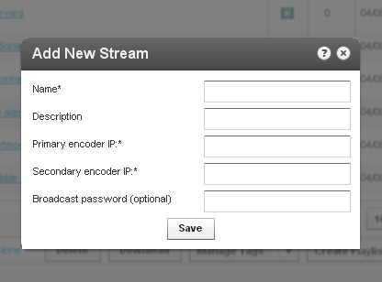

* **Name** – the name of the stream that will appear in the KMC entries list
* **Description** – a description of the stream (optional)
* **Primary encoder IP**–the public address that will be used for streaming (the computer where the client encoder is installed)

Note: your IP address can be retrieved by browsing from the computer where the FME is installed to<http://www.whatismyip.com/>

* **Secondary encoder IP** – if you are using two encoders for redundancy, fill in the secondary encoder. If you are using only a single encoder, simply copy the Primary encoder IP to the secondary encoder IP field.
* **Broadcasting password** – the password required for broadcasting. You will be required to fill this into your client encoder (FME). If you do not chose a password the system will create one for you.

Note: it may take up to 20 minutes until the stream is provisioned with the CDN.

**Broadcasting setup**

Go to the “Broadcasting” tab of the live entry you just created and copy the details to your FME, you can do this either by copying the details manually, or by using the “Export XML to FME” option:

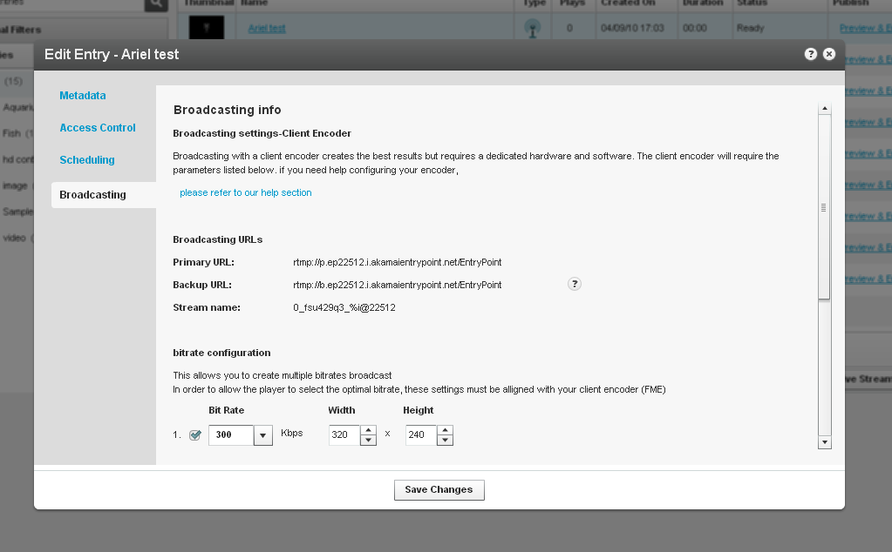

• Connect your camera to the broadcasting computer

• Run the FME software

• Configure your FME with the following parameters:

1. Select the relevant camera from the dropdown menu in the FME software

2. Enter the Primary URL and Secondary URL as displayed in the KMC

3. Enter the “stream name” as displayed in the KMC

4. Click “Connect”

5. Enter the “User Name” and “Password” as displayed in the KMC and click “OK”

6. Click “Start” 🡪 you are now broadcasting

7. When your broadcast is finished, click “Stop”

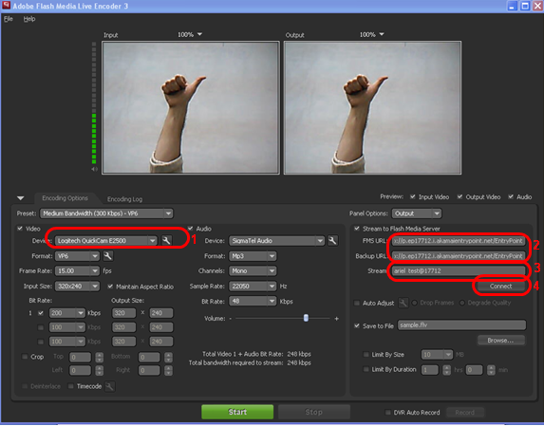

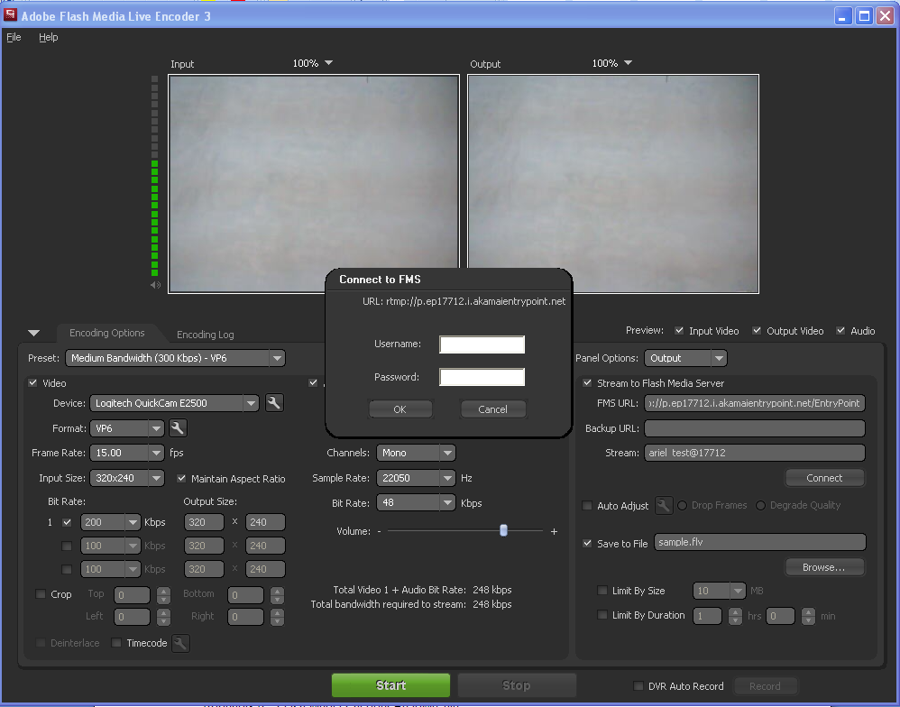

5

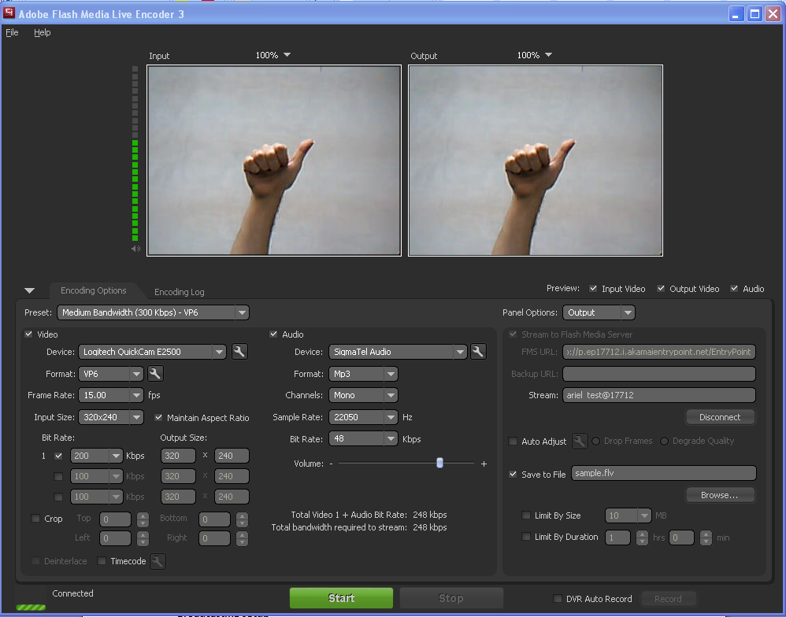

6

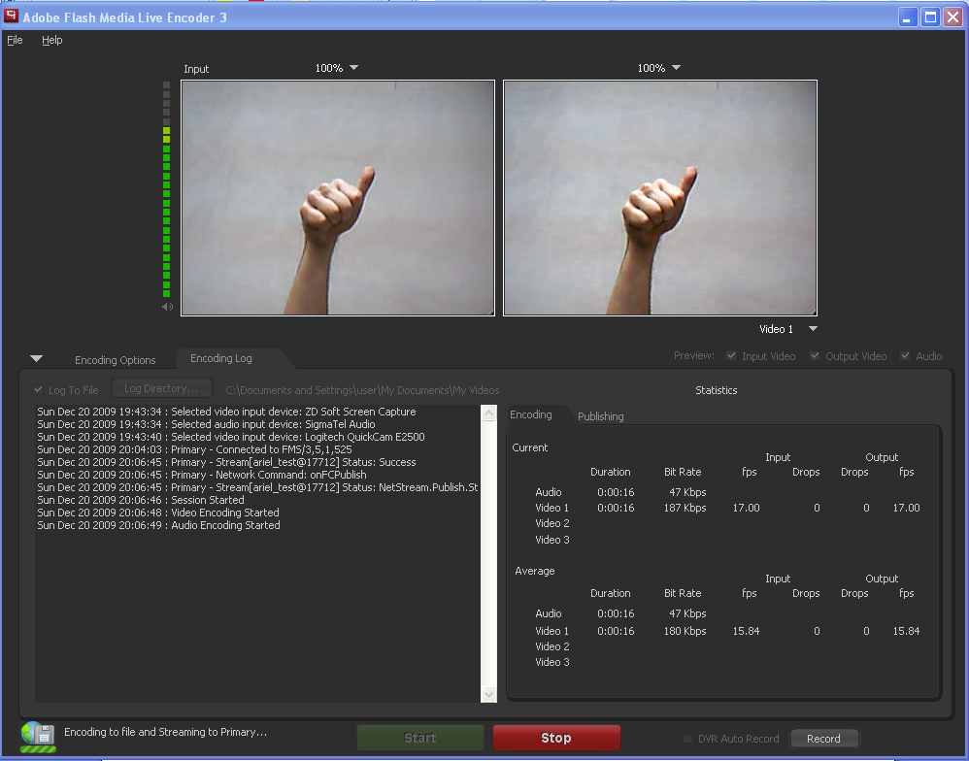

7

**Viewing setup**

1. Click on the “Preview & Embed” link from the KMC

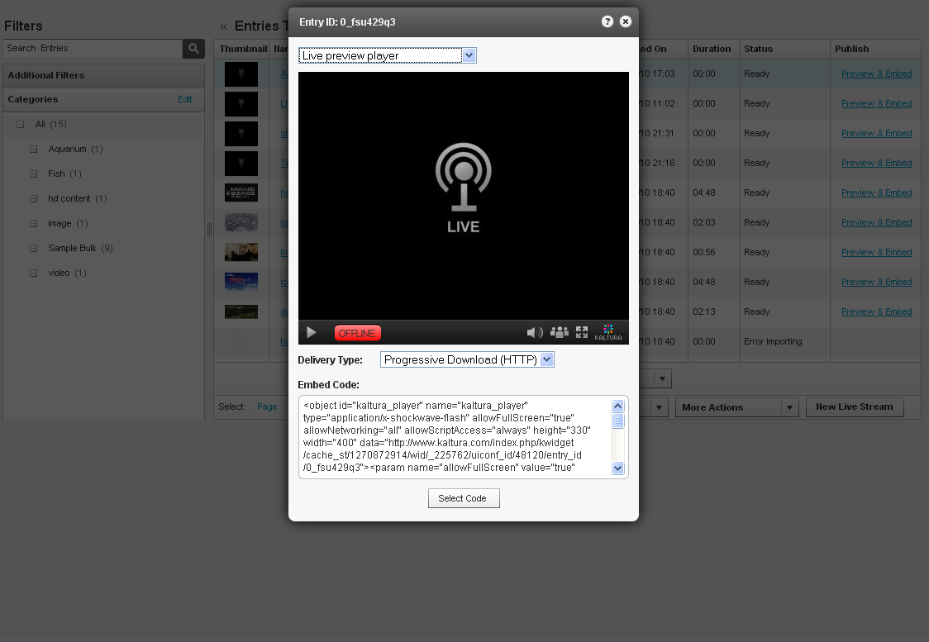

1. Select the player from the drop down menu and copy the embed code
2. Paste the embed code within an HTML page
3. Browse to the page where the embed code was inserted and press “play” on the video player.

**Advanced configuration options**

There are multiple factors that influence the video quality for live streaming. In order to receive good results you should optimize the settings based on your specific needs.

The table below can be used as a starting point for optimization and setup - it provides a rough estimate for the different factors based on the video dimensions.

|  |  |  |  |  |  |
| --- | --- | --- | --- | --- | --- |
| Video Dimensions | Bitrate  Required  (Mbps) | Camera Requirements | FME HW Requirements | Broadcaster Uplink, Viewer Downlink Requirements (Mbps) | Throughput example for 1000 concurrent viewers of  1 hour broadcast |
| 320x240 | 0.3 | support frame size &bitrate | Dual Core  2GB RAM | 0.4 | 135 GB |
| 640x480 | 1.4 | Quad Core Xeon 3GB RAM | 2 | 630 GB |
| 1024x720 | 3.5 | 8 Core  Xeon  3GB RAM | 5 | 1600 GB |

For further reading on how to set up these parameters in FME, as well as additional advanced configuration options please refer to the FME guide available at:

<http://help.adobe.com/en_US/FlashMediaLiveEncoder/3.0/Using/flashmedialiveencoder_3_help.pdf>

**Video Delivery Settings**

* **Video Delivery Settings**
  + **HTTP Delivery**
  + **RTMP Delivery with Adaptive Bitrate**
  + **Adding the flavor selector module**

**Video Delivery Settings**

Choose between two types of video delivery settings - HTTP Delivery or RTMP Delivery with Adaptive Bitrate.

**HTTP Delivery**

With HTTP Progressive download, the digital media begins downloading and once a specified amount of data becomes available to the video player, the media begins to play while the rest of the data continues to buffer.

To select this delivery setting go to Content > Manage > Preview and Embed and select Progressive Download (HTTP) from the drop-down menu.

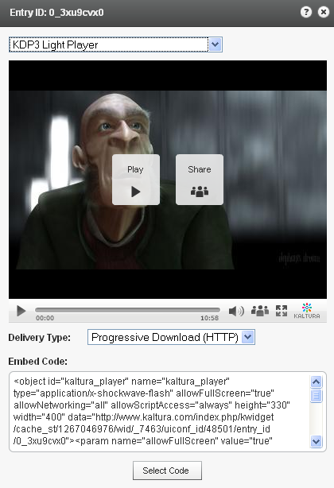

**RTMP Delivery with Adaptive Bitrate**

Adaptive bitrate is a technique of detecting a watcher's bandwidth and CPU capabilities in real time and then adjusting the quality of a video stream. The result is very little buffering, fast start time and a good experience for both high-end and low-end connections.

The RTMP protocol maintains a single persistent connection and allows real-time communication. Video and data are split into fragments, which then guarantees smooth delivery of video and audio streams.

To select this delivery setting go to Content > Manage > Preview and Embed and select Adaptive Streaming (RTMP) from the drop-down menu.

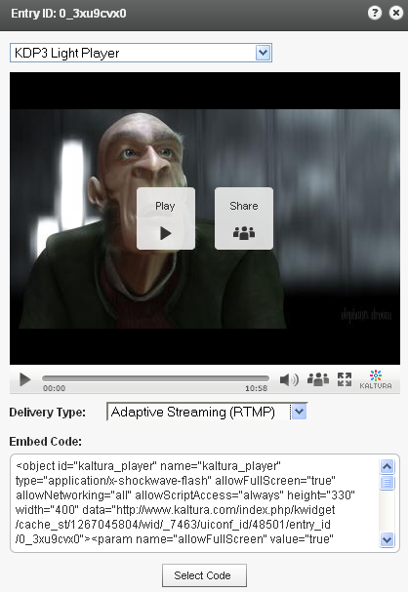

**Adding the Flavor Selector Module**

Any entry is available in various transcoding flavors. The flavor selector module allows the viewer to manually select the video flavor he wishes to watch, based on his preferences.   
Note: If you are broadcasting with Adaptive RTMP then the flavor selector will be set to “auto”.

In order to add the flavor’s selector module:  
  
1. Go to Studio > Players List and create a new player or edit an existing one.

1. In the Features tab, go to the Features List > Controls and check Flavor Selector.
2. Preview your selection and click Save Changes to complete the process.

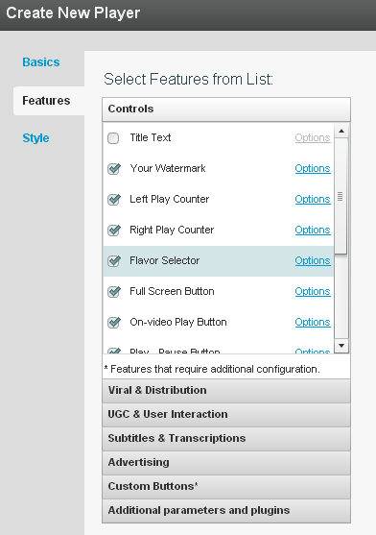

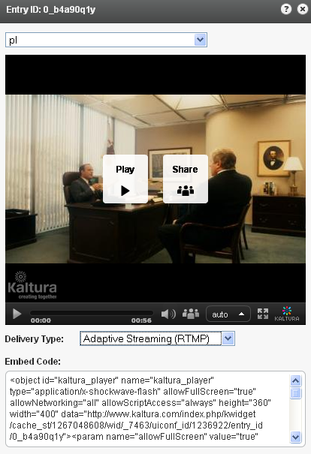

**Mobile Delivery**

* **Enabling Mobile Transcoding in Your Kaltura Account**
* **Mobile Transcoding for New and Existing Video**
* **Embedding an HTML5 Player**
* **Advertising on Mobile Devices**
* **Viewing Analytics for Mobile Devices**

Enabling Mobile Transcoding in Your Kaltura Account

To add mobile delivery to your account, contact your Kaltura account manager to purchase the mobile package.

**Mobile Transcoding for New and Existing Videos**

1. Once mobile transcoding has been enabled, go to the “Settings” tab > “Transcoding Settings” and select both mobile conversion flavors. Any video you upload from this point onwards will be transcoded for mobile.

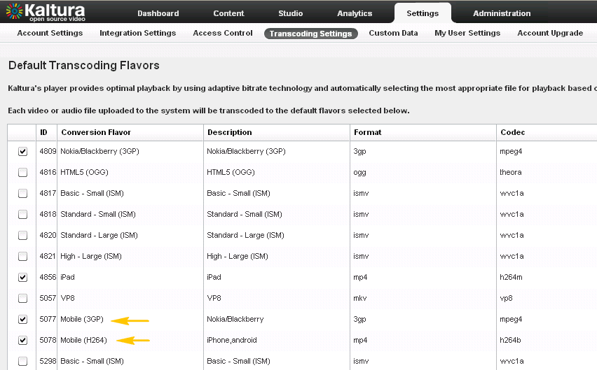

1. For existing videos you can either contact your account manager who will assist you with bulk encoding or transcode videos one at a time by going to “Content” > “Manage” and clicking on the video you would like to transcode. Select “Flavors” from the window’s side menu, find the mobile transcoding flavors and click “Convert”.

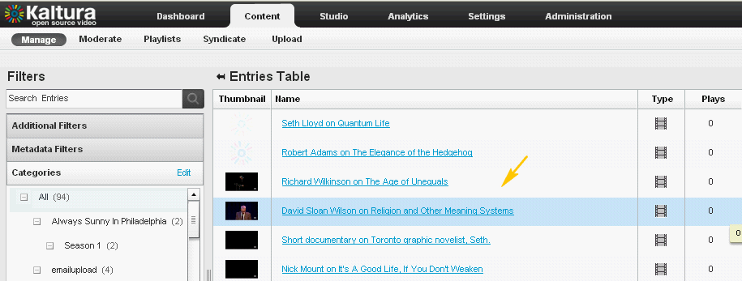

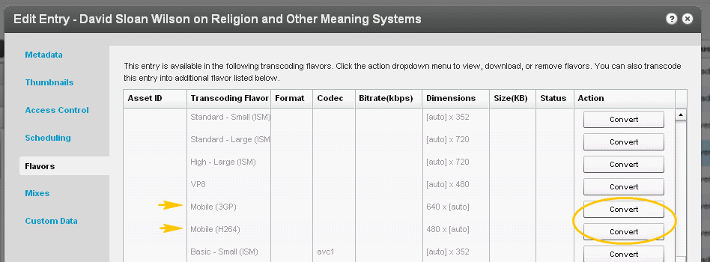

**Embedding an HTML5 Player**

1. To grab the embed code for a video in an HTML5 player go to “Content” > “Manage” and select “Preview and Embed” for the selected video.

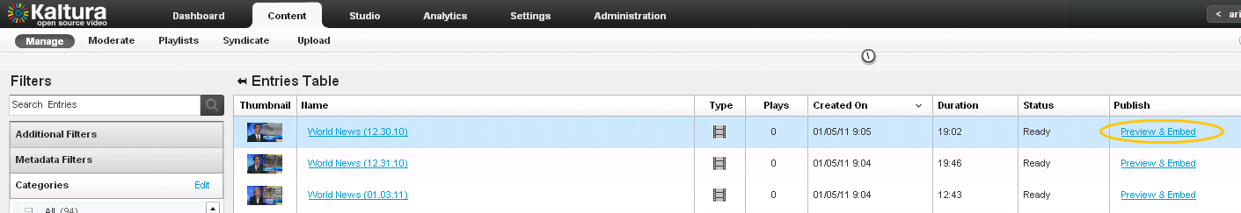

1. After selecting the player and flash delivery type, check the “Support iPhone &iPad and HTML5” box. This will add a JavaScript code to your embed code that identifies the device and switches to HTML5 player when accessed from iOS Devices.
2. Copy the embed code and paste on your site.

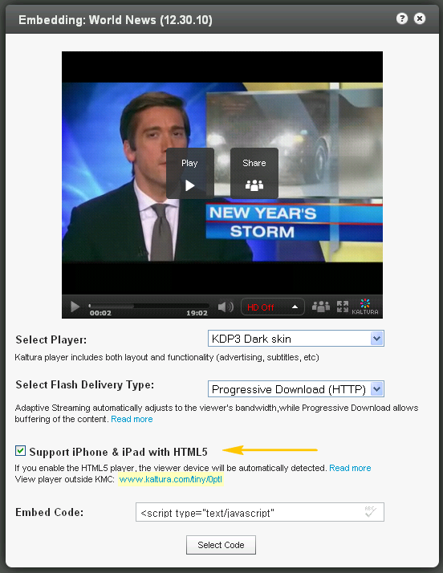

**Advertising on Mobile Devices**

The advertising settings applied to your player will also apply for mobile delivery. Visit the advertising section for more information on advertising. The following table summarizes current advertising support for mobile:

|  |  |  |
| --- | --- | --- |
| **Device** | **Supported Ad type** | **Notes & Limitations** |
| iPhone | VAST Pre-roll  Bumper video  VAST Post-roll | * Ads are played back in the native player * Player controls are not disabled during playback  (user can skip the ads) * Ads are not clickable * Ads must be encoded for the iPhone (H264) |
| iPad | VAST Pre-roll  Bumper video VAST Overlay  VAST Post-roll | * Ads must be encoded for the iPad (H264) |
| Android  (ver 2.2 and up) | All | Android from version 2.2 supports Flash playback with all ads integration as in Flash player. |

**Viewing Analytics for Mobile Devices**

Analytics from mobile devices are aggregated into the general analytics report in the “Analytics” tab

**Access Control Settings**

* **Access Control Settings**
  + **Domain Restrictions – Restricting content to specific domains**
  + **Geo Restrictions - Restricting content to specific Countries**
  + **Assigning an Access Control Profile to an Entry**
  + **Content Scheduling**

**Access Control Settings**

An Access Control Profile defines authorized and restricted domains where your content can or cannot appear, countries from which it can or cannot be viewed, Kaltura Network preferences and security settings. In this area you can view existing profiles and create new ones.

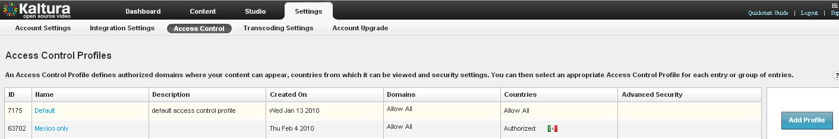

**Domain Restrictions – Restricting content to specific domains**

1. Go to the Settings tab> Access Control section and click Add Profile.
2. Enter an informative name for the new profile and give it a description.
3. Under Authorized Domains you can choose between allowing all domains, listing a group of approved sites or a list of domains to exclude.
4. To add or remove a domain, click the ‘+ Add another domain’ or ‘– Remove selected domains’ links.
5. Continue to add other parameters or click Create New to save your new profile.

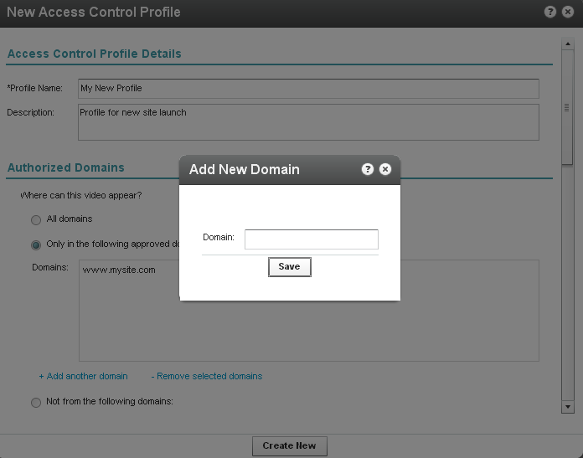

**Geo Restrictions - Restricting content to specific** **countries**

1. Go to the Settings tab> Access Control section and click Add Profile.
2. Enter an informative name for the new profile and give it a description.
3. Scroll down to the Authorized Countries section and choose to allow viewers from any country, select a group of approved countries or a group of excluded countries.
4. Use the ‘+Add / -Remove countries’ link to add or remove countries.
5. Continue to add other parameters or click Create New to save your new profile.

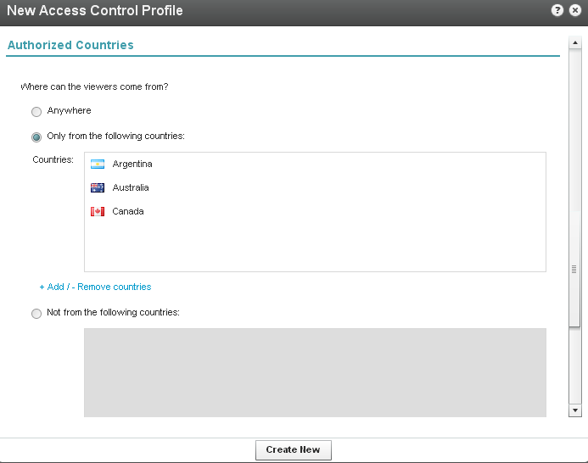

**Assigning an Access Control Profile to an entry**

1. Go to Content> Manage section and click on the Entry to which you want to assign an Access Control Profile.

2. Go to the Access Control tab and select an existing Profile from the drop-down menu.

3. Click Save Changes to complete the process

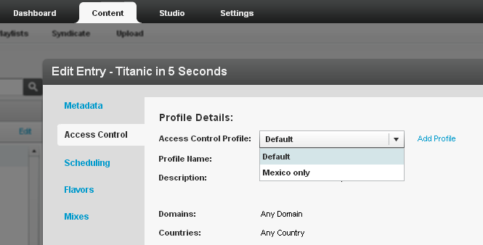

**Content Scheduling**

Content Scheduling determines when your entry will be displayed on your website.

1. Go to Content>Manage section and click on an Entry.

2. Go to the Scheduling tab and select and set your specific time range.

3. Click Save Changes to complete the process

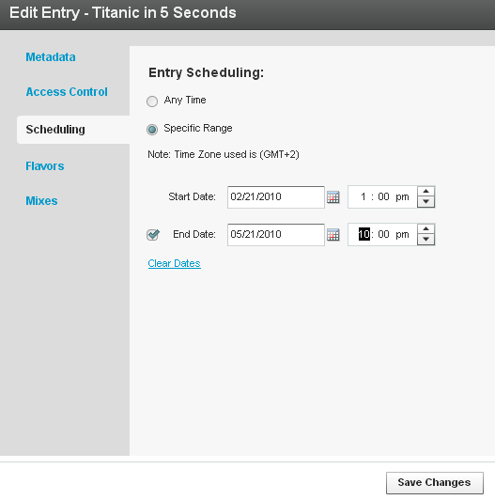

**Custom Metadata**

* **Adding Custom Metadata Fields**
* **Setting Values for Custom Metadata Fields (Per Entry)**
* **Searching Based on Metadata Fields**

**Adding Custom Metadata Fields**

1. To create an additional field, click the “Add Field” button.

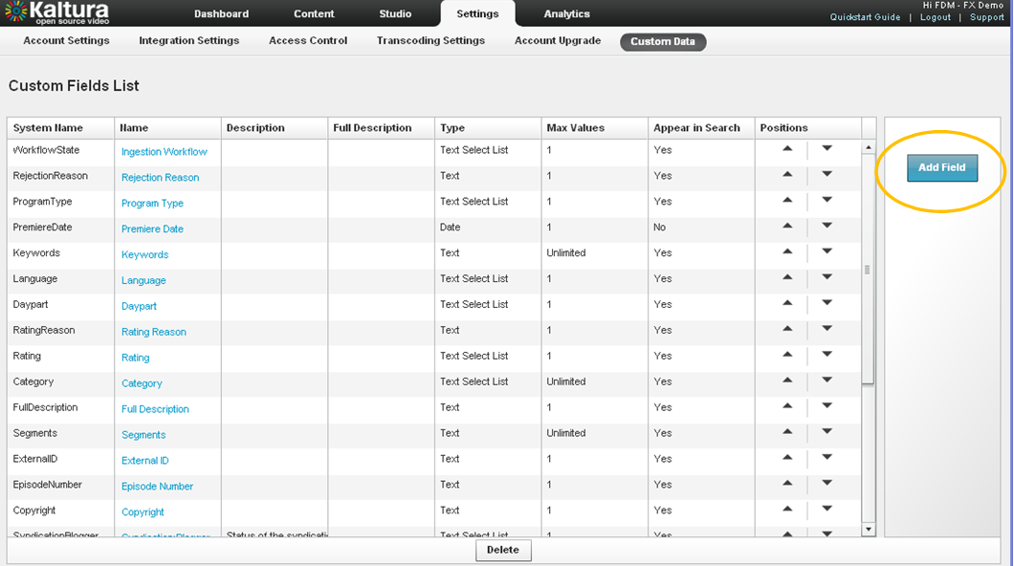

1. Select the field type from the following options:
   * Text field – values are free text
   * Text select list – this is similar to the text field, but allows the publisher to set a predefined list of values from which the user can choose (for example select the country out of a list of options)
   * Date ‐ a date field
   * Entry ID link ‐ a link to a different entry (asset) in order to create a compound structure.   
     An example of this would be multiple high res images relating to the video.

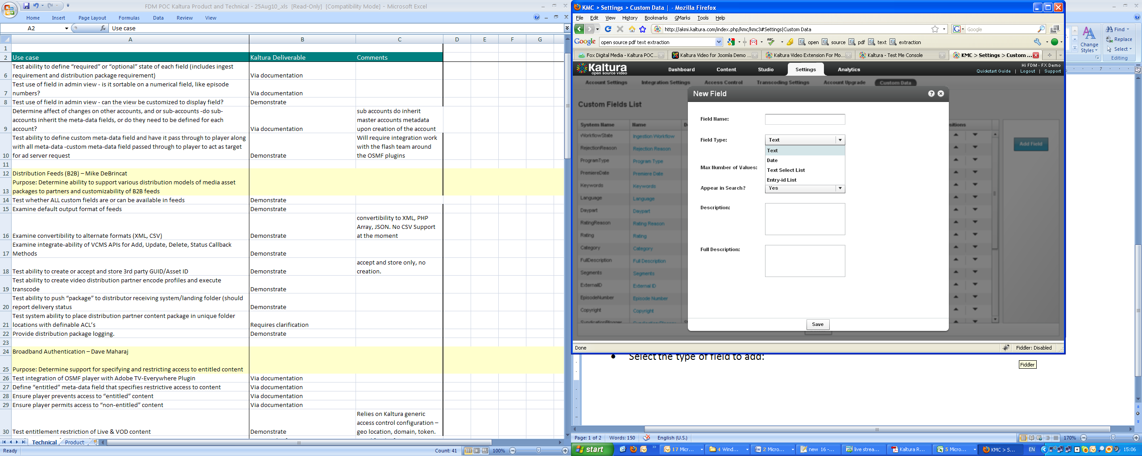

1. Add a description, or full description
2. Change the order of the fields by clicking the up and down arrows

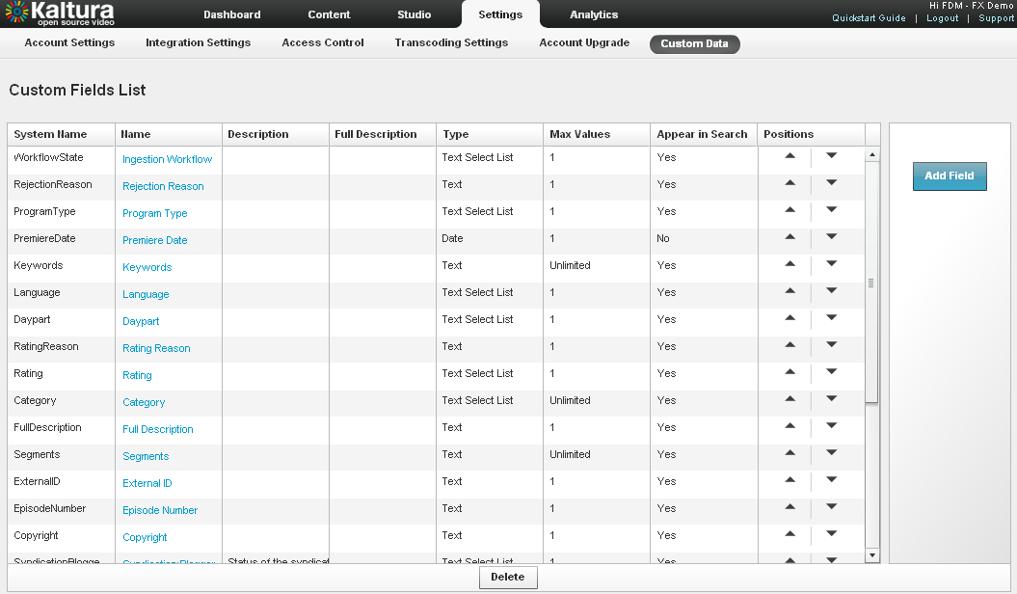

**Setting Values for Custom Metadata Fields (Per Entry)**

To add values to the custom metadata fields create, go to the entry drilldown window

(It is also possible to set them as part of bulk upload or API)

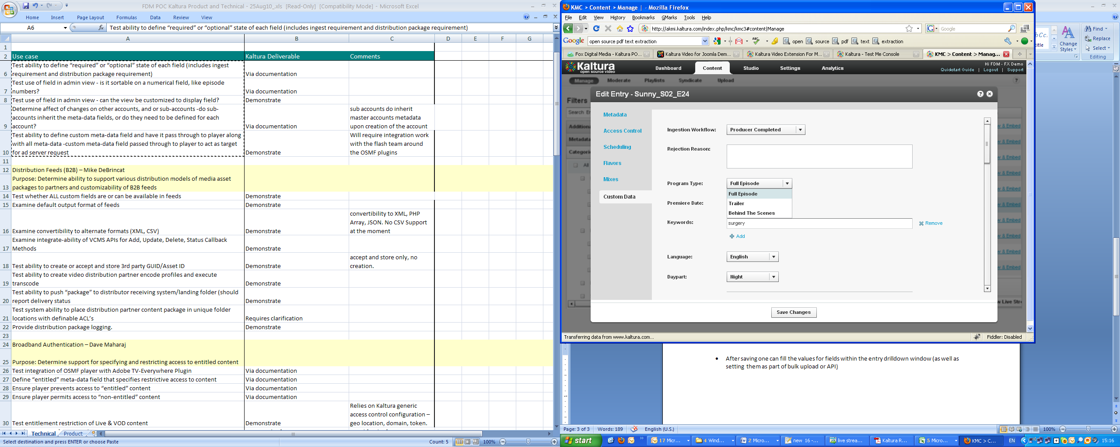

**Searching Based on Metadata Fields**

Custom fields can be used to perform a search and create playlists. To search textual fields use the regular search box, for canned lists use the Metadata Filters.

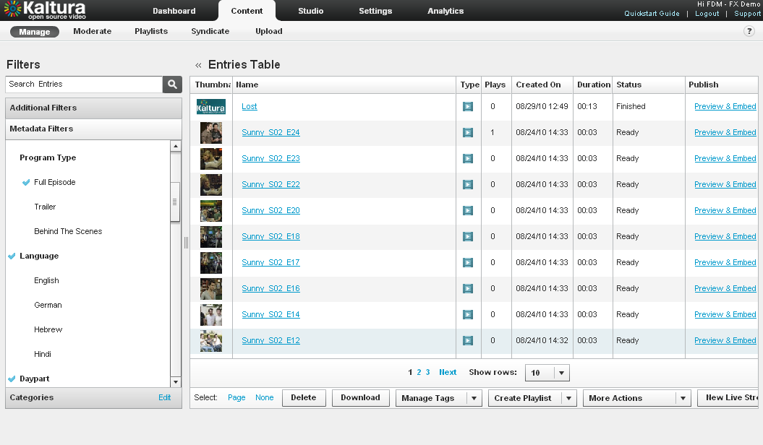

**Advertising**

* **Advertising**
  + Connecting with any ad server that supports IAB standards (VAST 1.0 / VAST 2.0)
    - Configuring Companion Ads
    - Targeting with an Ad Server
    - How to locate the Ad Tag URL
  + Connecting with Ad Servers and networks via AdapTV
  + Connecting with Tremor Media

**Advertising**

**Connecting with any ad server that supports IAB standard (VAST 1.0 / VAST 2.0)**

Most of the leading Ad Servers and Ad Networks are now VAST compliant. This includes DoubleClick, Dart for publisher (DFP), Microsoft Atlas, OpenX, ScanScout, and many others. To see the full list of servers and networks that comply with VAST please refer to the IAB website: <http://www.iab.net/iab_products_and_industry_services/508676/compliance/679253>

1. To add any ad server that supports the VAST standard you first need an ad tag URL from your ad server, To learn more browse the “how to find Ad Tag URL” section below
2. Go to the studio tab and edit an existing player or create a new one
3. Go to the Advertising section
4. Enable ads for this player
5. Select VAST Ad Server from the “Ad Source” drop down

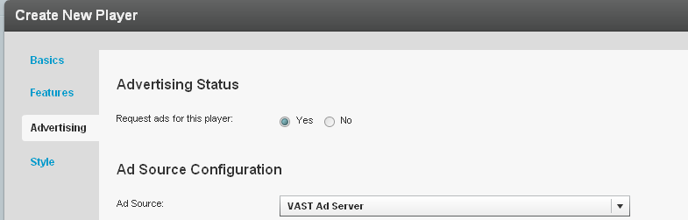

1. For Pre-roll ads select the Pre-roll section, set it to “enabled” and paste the Ad Tag URL received from the ad server

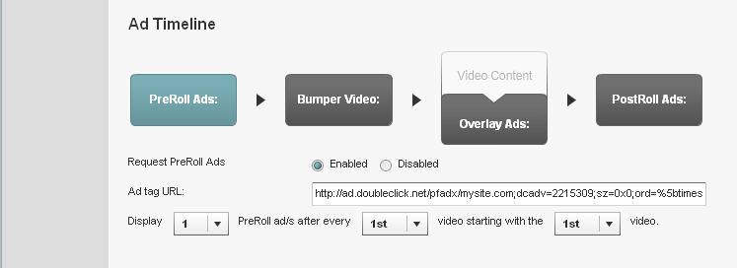

1. For bumper videos (a bumper video is a static pre-roll that does not use an ad server) select the bumper section, and set it to enabled. Select a Kaltura entry id that will be used as the bumper, and add the click URL.

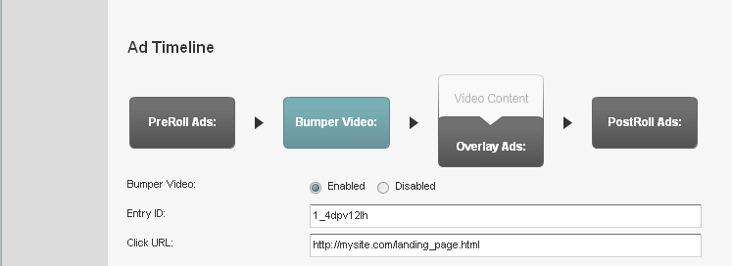

1. For Overlay ads select the overlay section, set it to Enabled and paste the Ad Tag URL received from the ad server.

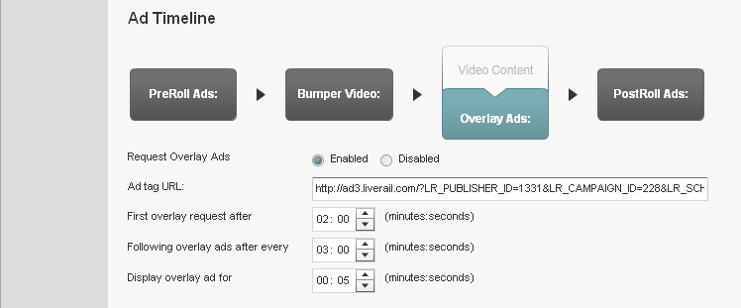

1. For Post-roll ads select the Post-roll section, set it to enabled and paste the Ad Tag URL received from the ad server

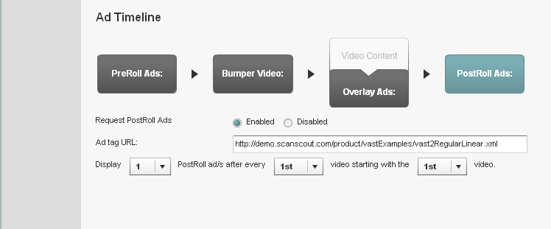

Configuring Companion Ads

Companion Ads are “text, display ads, rich media, or skins that wrap around the video experience, and can run alongside either or both the video or ad content. The primary purpose of the Companion Ad product is to offer sustained visibility of the sponsor throughout the video content experience.”

- <http://www.iab.net/wiki/index.php/Companion_Ad>

Kaltura’s platform makes it easy to add Companion Ads in either HTML or Flash. After you’ve configured your player (see the “Configuring The Kaltura Video Player” section earlier in this document), edit the player and navigate to the Advertising tab. Scroll down a bit and you’ll see the “Player Configuration” section:

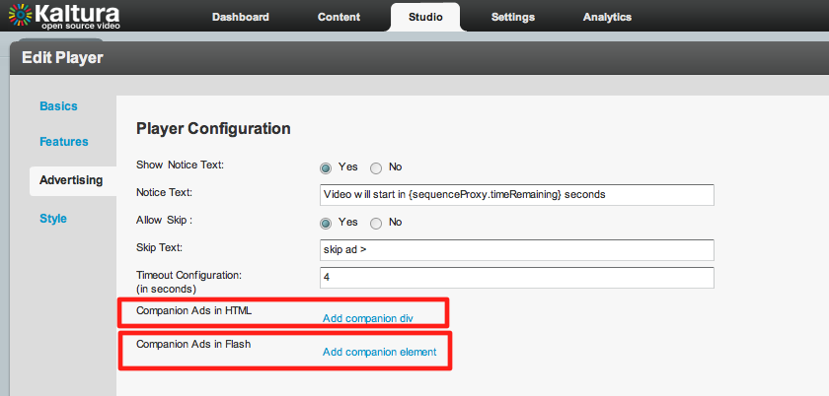

Here, you can choose to configure HTML or Flash-based Companion Ads.

1. Companion Ads in HTML

Click on the “Add companion div” text in the “Player Configuration” section. You’ll get entry fields to enter the CSS “id” of your companion ad and the dimensions in pixels. You can click on the “Add companion div” text multiple times to enter more ad regions:

**Note: make sure the dimensions you enter here match the dimensions of your served ads exactly.**

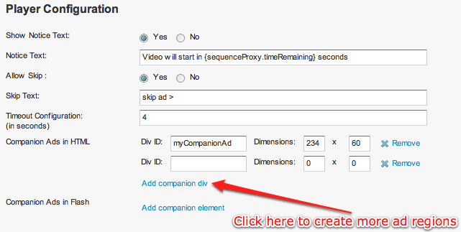

Enter the CSS div id and dimensions (in pixels) for each ad region.

In the web page where your Companion Ads will display, you need to include a JavaScript file as well as a corresponding HTML <div> tag with a matching id for each region you create:

<html>

<body>

<head>

….

**<script src="http://www.kaltura.com/javascript/VAST/companionAdFunc.js" type=**

**"text/javascript"></script>**

….

</head>

<body>

….

<object id="kaltura_player" name="kaltura_player" type="application/x-shockwave-flash" ……… </object>

**<div style= "width: 234px; height: 60px;" id="myCompanionAd">**

**</div>**

….

</body>

</html>

2. Companion Ads in Flash

Click on the “Add companion div” text in the “Player Configuration” section. You’ll get entry fields to enter the CSS “id” of your companion ad and the dimensions in pixels. You can click on the “Add companion div” text multiple times to enter more ad regions:

**Note: make sure the dimensions you enter here match the dimensions of your served ads exactly.**

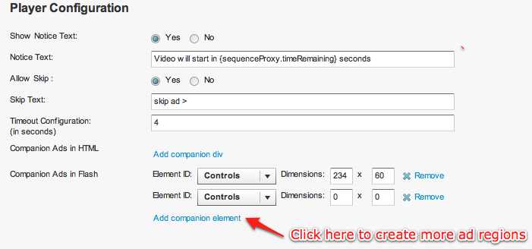

There are either two or three possibilities for the “Element ID” pulldown menu. If you created a Kaltura Playlist Player (for details on creating new players, see the “Configuring The Kaltura Video Player” section), then you will see three options:

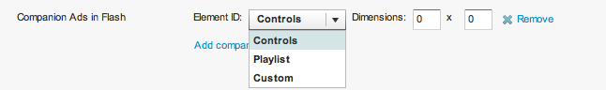

If you created a regular (non-Playlist) Player, then you will see two options:

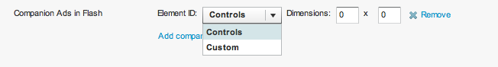

The “Custom” option is not available, so do not use it. If your companion ad will appear in the regular player window above the player controls, then select “Controls”. If your ad will overlay the Playlist, then select “Playlist”. Enter the dimensions of your ad (in pixels) in the “Dimensions” text fields.

Here’s a Kaltura Playlist Player in a horizontal configuration:

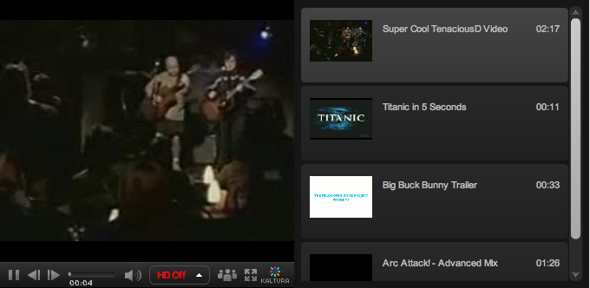

In the example below, the same player plays a preroll ad in the main player area while a Flash Companion Ad is displayed in the playlist area:

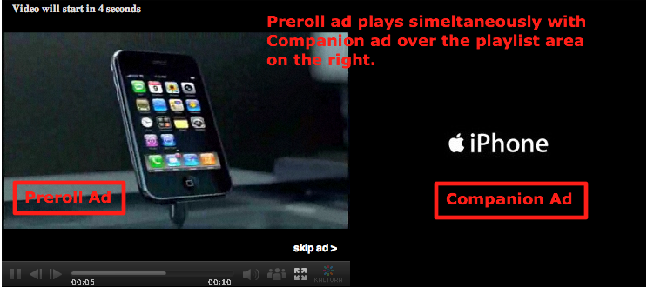

**Targeting with an Ad Server**

While ads targeting is performed within the ad server, Kaltura’s advertising module is designed to pass all the relevant targeting information to the ad server.

Targeting information can be set in several levels:

1. Targeting per player and ad slot – you can add additional key value pairs within the adtag URL. The ad server will use these for targeting.
2. Targeting per content item - The Kaltura VAST module supports dynamic pulling of metadata from the content item, and passes it to the ad server.  
   For example for targeting a specific content category :
   1. Drag content items into the category within the KMC  
      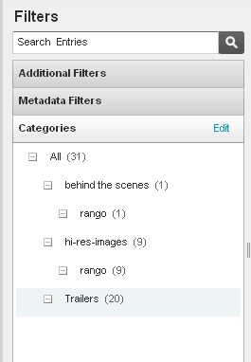
   2. Define the additional parameter in your ad server.   
      For example in OpenX set the “category” parameter through “Site - Variable”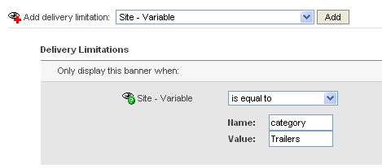
   3. Add category template category={mediaProxy.entry.categories} into the AdTag URL. At runtime this template will be populated with the actual values for each video played.

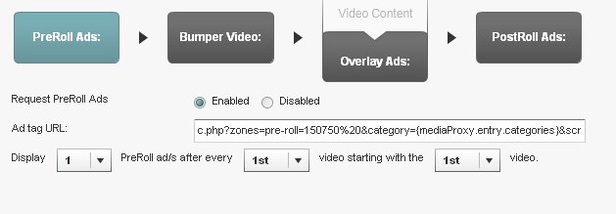

The following targeting templates are available for targeting  
category={mediaProxy.entry.categories}  
tags={mediaProxy.entry.tags}  
name={mediaProxy.entry.name}  
id={mediaProxy.entry.id}

1. Targeting per viewer  
   In some cases the targeting information is not defined per content item, but per viewer.  
   To support these cases the Kaltura VAST module dynamically pulls metadata from the website via flashvars passed to the player.  
   For example targeting per a specific age group. This example assumes that the hosting site has a user database and would like to further target known users.  
   1. Pass the viewer age from your internal DB to the player via Flashvar.

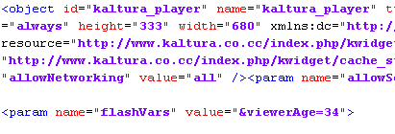

* 1. Define the additional parameter in your ad server.   
     For example in OpenX, set the “viewerAge” parameter through “Site - Variable”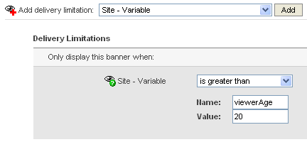
  2. Add the flashvar template into the AdTag URL, this template will be populated in runtime with the actual values.   
     The template is FLASHVAR_NAME={configProxy.flashvars.FLASHVAR_NAME }and in the viewerAge example it would be:  
     viewerAge={configProxy.flashvars.viewerAge}

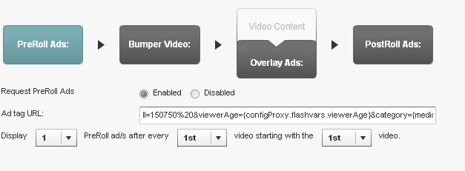

**How to locate the Ad Tag URL**

**DFP**In DFP there is a “Tag Generator” utility in the dashboard to generate the ad tag url.   
The ad tag url (<http://ad.doubleclick.net/pfadx/mysite.com/>... ) is at the bottom of the widget.  
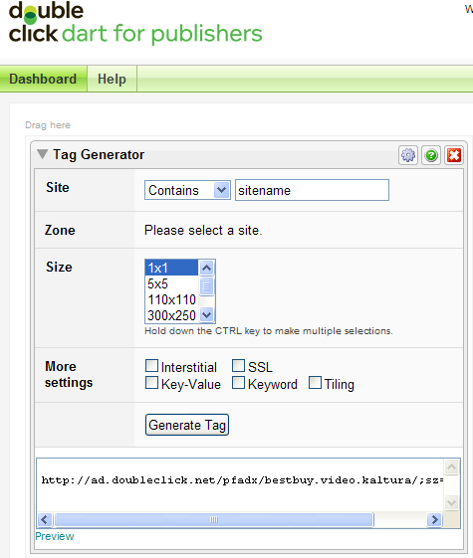  
  
 **OpenX**  
In OpenX the adtag URL is linked to an OpenX Zone, in the following format:  
*http://[OPENX_INSTALL]/fc.php?script=bannerTypeHtml:vastInlineBannerTypeHtml:vastInlineHtml&source=&format=vast&charset=UTF_8&nz=1&zones=z1=[ZONE_ID]*for openX hosted, the URL is d1.openX.org. ,   
from within your OpenX account you can retrieve the zone Id.  
for example for zone id 150750 in openX hosted the ad tag url would be:  
<http://d1.openx.org/fc.php?script=bannerTypeHtml:vastInlineBannerTypeHtml:vastInlineHtml&source=&format=vast&charset=UTF_8&nz=1&zones=z1=150750>

**AdapTV (via VAST)**Copy the “Specific Ad Tag” from the Ad screen

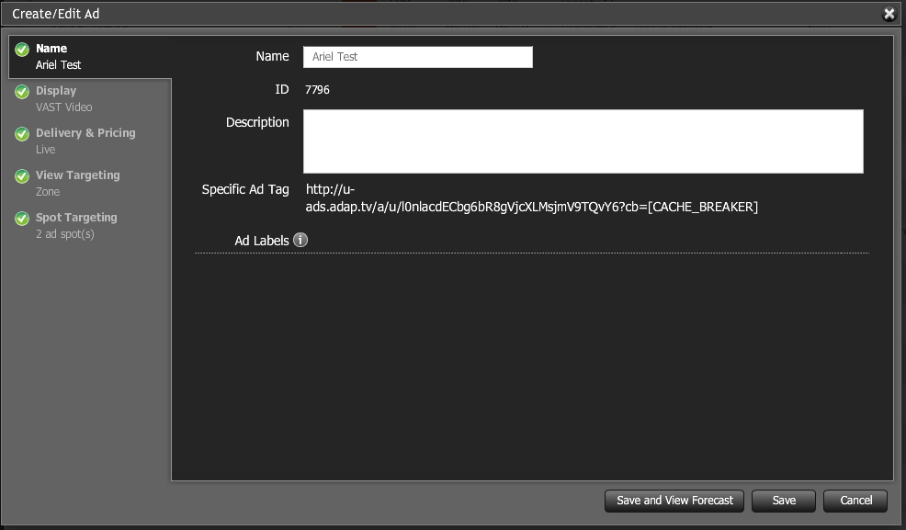

Connecting with Ad Servers and networks via adap.tv

To add adap.tv’s service to your Kaltura players start by signing up with adapt.tv ([Contact us](http://corp.kaltura.com/about/contact) to learn more) – you will then receive an adapt.tv Partner Key.

1. Go to the Studio tab and edit an existing player or create a new one
2. Go to the Advertising section
3. Enable ads for this player
4. Select adapTV from the “Ad Source” drop down
5. Enter your adapt.tv Partner Key in “Key Value Pairs” section, in the following format “key=[YOUR ADAPTV KEY]”

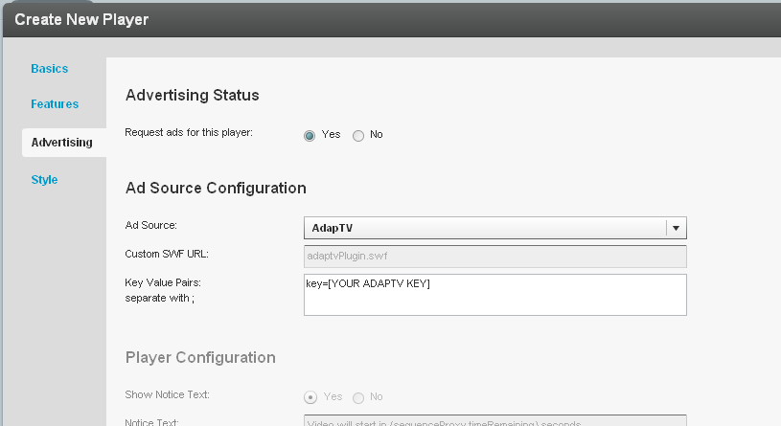

1. Target, manage and customize your ads via the [adap.tv console](http://publishers.adap.tv/osclient/)
2. Via adapt.tv you can also connect to additional ad servers & ad networks such as AdTech, Atlas, DART, OpenX, Advertising.com, ScanScout , SpotExchange, Google AFV, AdBrite, AdDynamic, AdEngage, AdFish, AdoTube and over 20 other networks and servers.  
     
   For example connecting to DART via adapt.tv would simply require pasting the Ad Tag URL that the AdTech Server supplies.

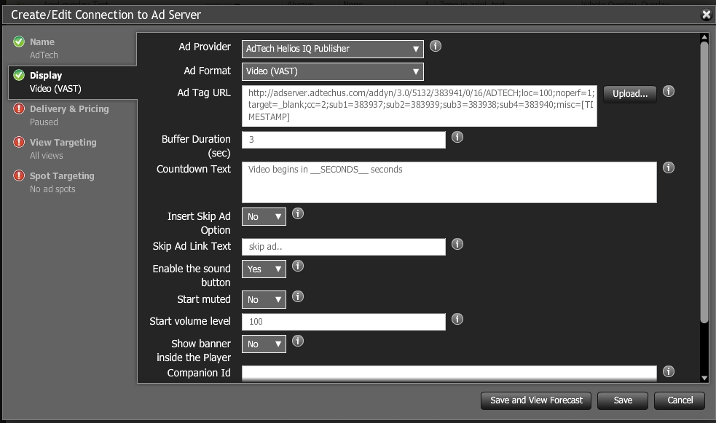

Connecting with Tremor Media

Adpa.tv onesource console: integrating with additional ad servers

1. To add Tremor Media’s service to your Kaltura players start by signing up with Tremor Media ([Contact us](http://corp.kaltura.com/about/contact) to learn more) – you will then receive a Tremor Media Program ID.
2. Go to the studio tab and edit an existing player or create a new one
3. Go to the Advertising section
4. Enable ads for this player
5. Select Tremor from the “Ad Source” drop down
6. Enter your acudeo Program id in the “Key Value Pairs” section, in the following format:  
   “progId=[YOUR ACUDEOPROGRAM ID]”. Additional targeting parameters should be separated with semicolons.

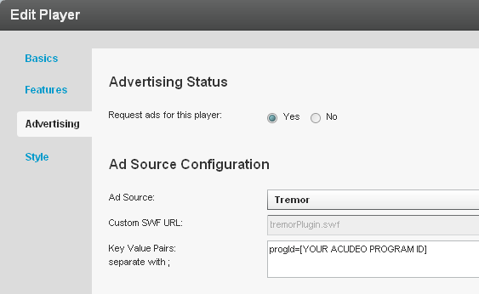

1. Target, manage and customize your ads via the [Tremor Media console](https://acudeo.tremormedia.com/) (Acudeo).  
     
   Via Tremor Media’s Acudeo console you can specify ad sources for each ad slot within your content.  
   Program id’s are available in the program list

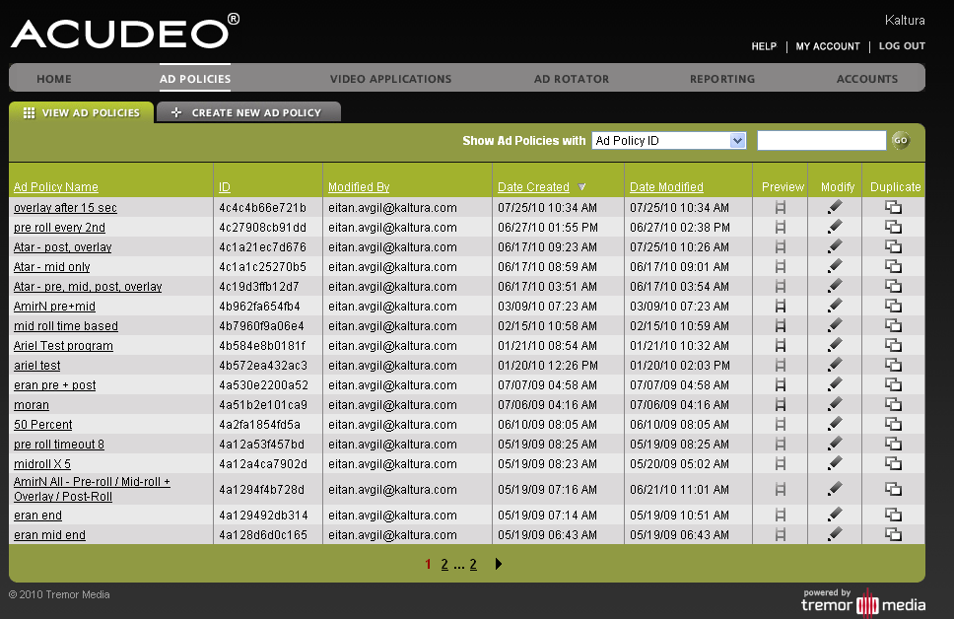

To learn more about advertising for mobile go to the “Mobile Delivery” section

**Player Design**

* **Designing and Configuring a New Player** **or Playlist**
  + Configuring the player settings
  + Configuring the player features
    - Additional feature configuration options for playlists
  + Configuring the player style
  + Creating a Multiple Playlist

**Designing and Configurin****g a New Player or Playlist**

The Studio section of the KMC enables you to create new configurations and design for players and playlists. Add, remove and adjust multiple buttons and features, and create a look to match your site.  
  
Start by logging-in to the KMC and going to the Studio tab. Select the type of player you would like to create: player, player with playlist (horizontal/vertical) or player with multiple playlists.

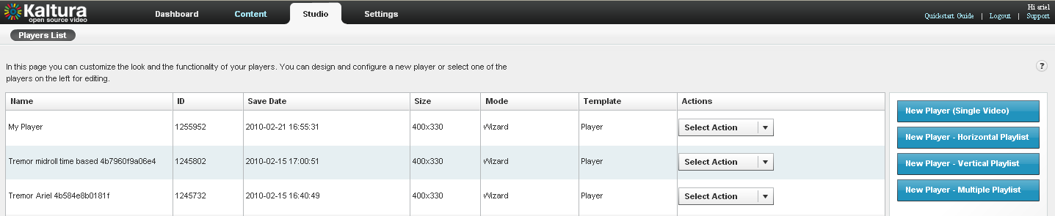

**Configur****ing the Template Settings**

1. Begin by selecting a name for your player (required). We suggest choosing an informative name – it will help you when you're ready to embed players into your site.

2. Set the Video Ratio – select normal/wide and opt to either keep or stretch your media to fit the player when the media and player aspect ratios are different.

3. Select auto-play features

4. If you're creating a Player & Playlist you'll also see the Playlist Controls – check "Automatically continue" to play the playlist media consecutively. For playlists with images, set the duration for images to be displayed during the continuous play of the playlist.

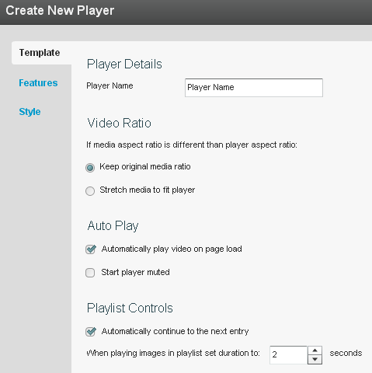

**Configuring the Player Features**

In the Features Tab you can select the features (buttons, layers and modules) to be included in your player. Any changes you make will appear in the preview area (click Preview button to see changes you’ve made).

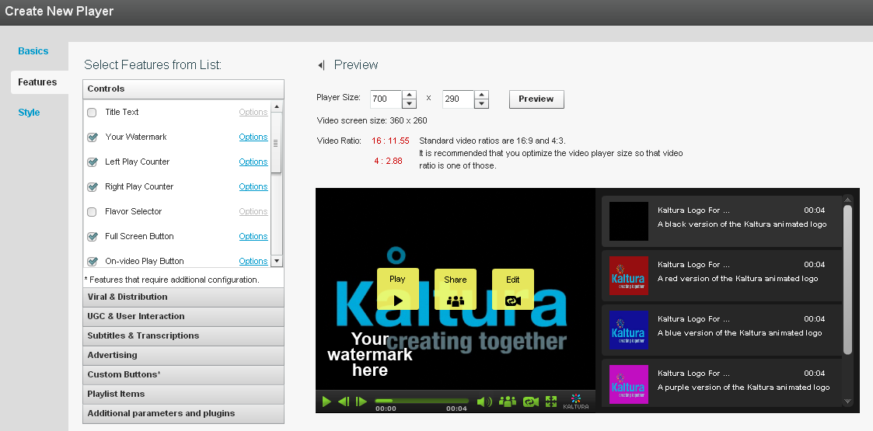

**Features List:** Select the features you want to add and remove

**Preview Pane:** Change the player size and preview your Features List changes

The features list is made up of different sections, controlling the various features of the player.

Player (A) below displays the default settings. The following instructions will show you how to create a more customized player, for example, Player (B).

**Note that Player (B) presents only one of many set-up scenarios.** There are many configuration options within this section. Click the Help button on the top right of any page to learn more.

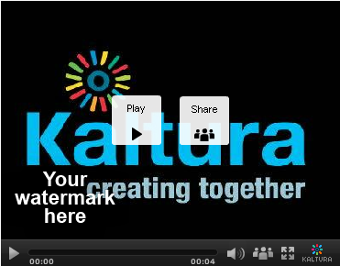 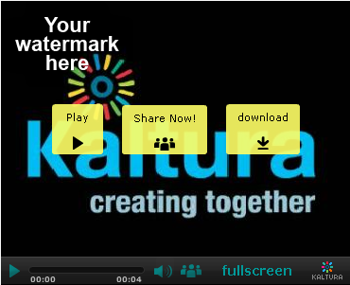

Player B

Player A

1. Change the location of the watermark logo  
     
   Go to Controls 🡪 Watermark 🡪click Options  
   In the Watermark Location drop-down menu select Top Left, click Preview and then Apply to confirm your choice

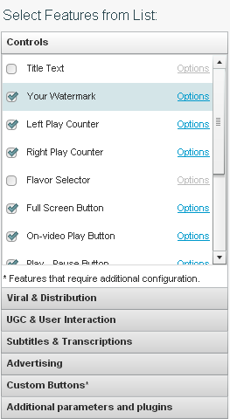 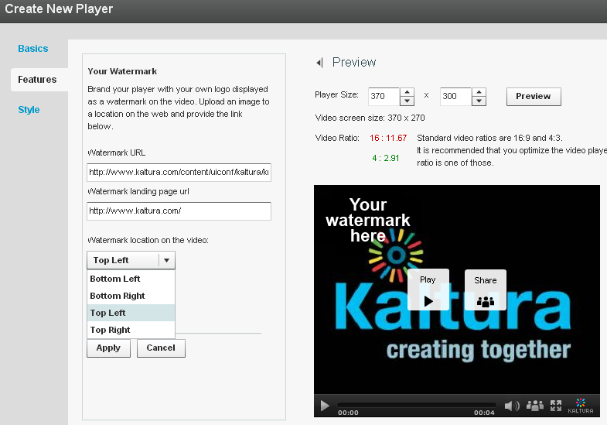

1. Change the label of the Share button  
     
   Go to Viral & Distribution 🡪 Share Button 🡪 Options  
   Locate the Label field and change the default text to "Share now!", then click Apply  
     
   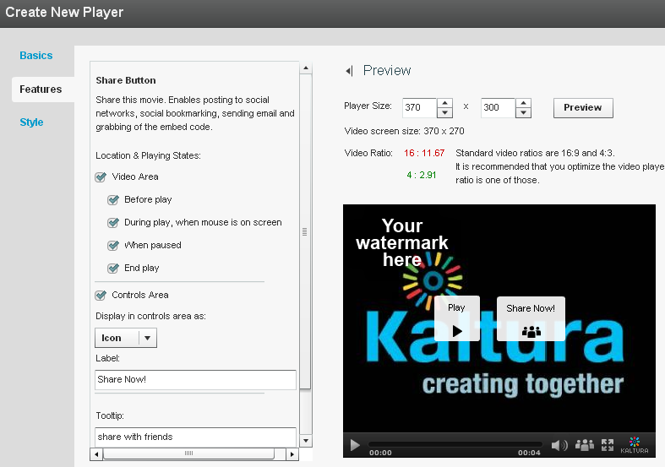
2. Add Download button to the video area only  
   Go to Viral and Distribution🡪 check the Download feature 🡪 click Options  
   Clear the Controls Area option checkbox

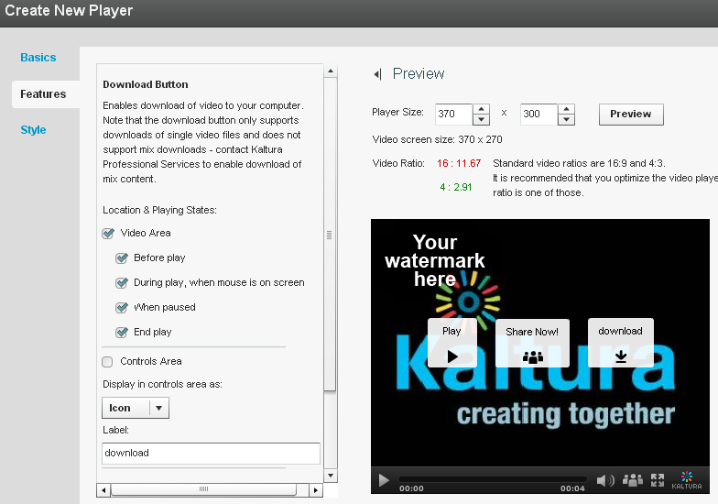

1. Change existing Fullscreen button on the control area to text button   
     
   Go to Controls 🡪Fullscreen🡪 Options  
   In the Display in Controls Area drop-down select Label  
   If desired, change the label text in the Button Label field

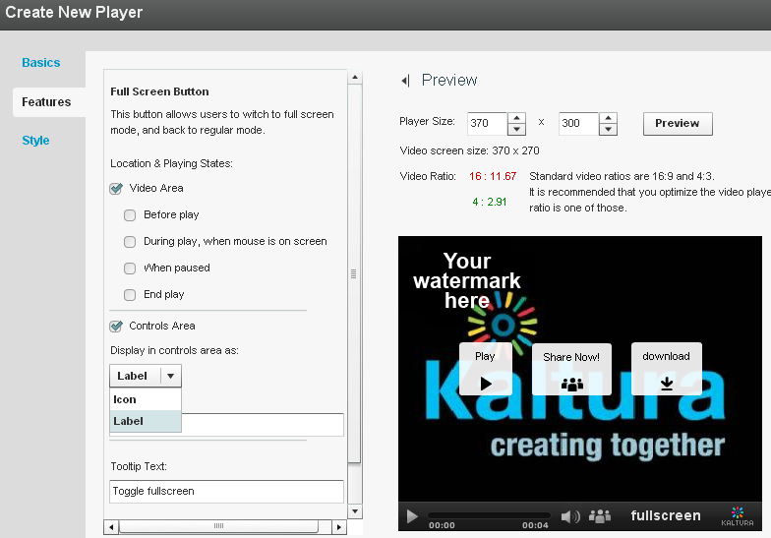

**Additional feature configuration options for playlists**   
  
When creating a playlist (either with one or multiple tabs) you will see additional configuration options under the Playlist Items section. This will allow you to display various types of information for each of the playlist items, such as number of plays, tags, rank etc.  
  
🡪Play around some more to get a feel for the Features section and then continue to customize the player's design in the Style section.

**Configuring the Player Style**

In the Style Tab you can select the theme, colors and fonts for your player.

1. Select either a dark or light player skin.
2. Choose the colors of the icons/labels and online video buttons by clicking the small colored squares. This will open a color picker where you can select a color or enter a color value.

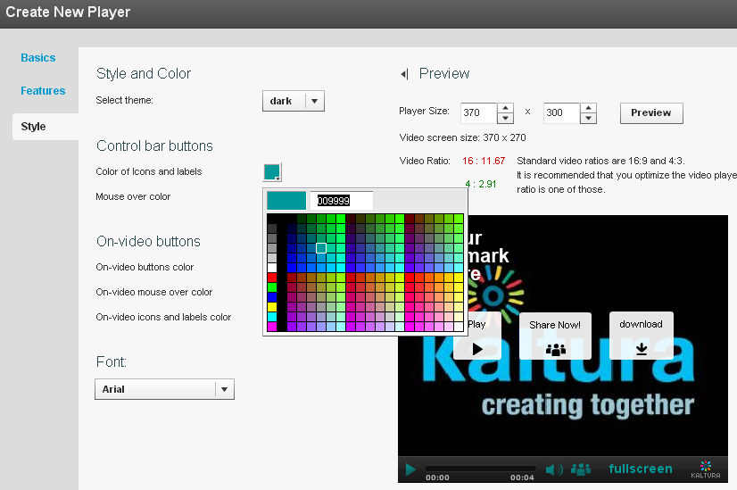

1. Change the font.
2. Once you are finished defining your player template, features and style, click Save Changes to complete your player configuration and design.
3. Your new player will now appear in the player list

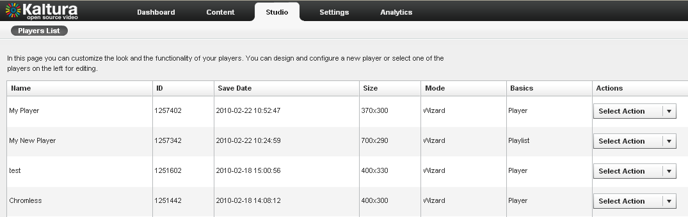

**Creating a Multiple Playlist**

A Multiple Playlist is a playlist with a multiple tabs, each containing a different playlist.  
Creating a Multiple Playlist:

1. If you haven’t already, create the playlists that you wish to use (learn how to create a playlist)
2. In the Studio Tab, select New Player – Multiple Playlist

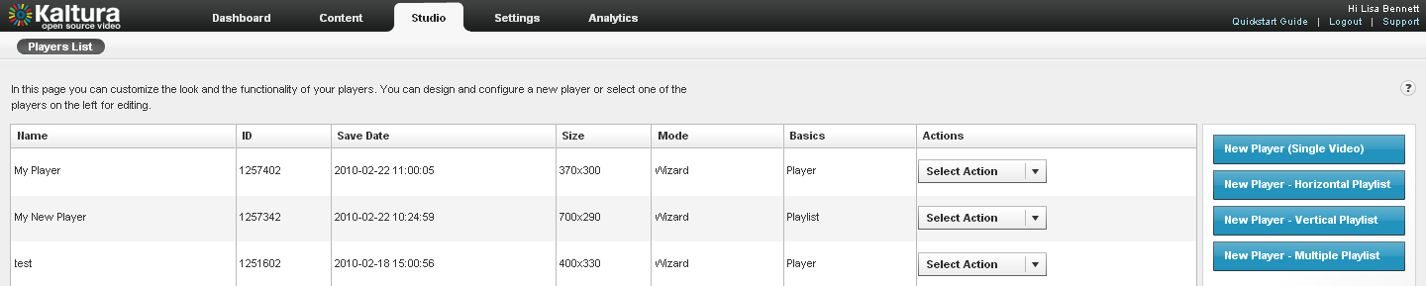

1. Design and configure your playlist as described above.
2. Continue to the Content tab and add pre-existing playlists to your new Multiple Playlist by selecting them and clicking the arrows.
3. Save Changes to complete the process.

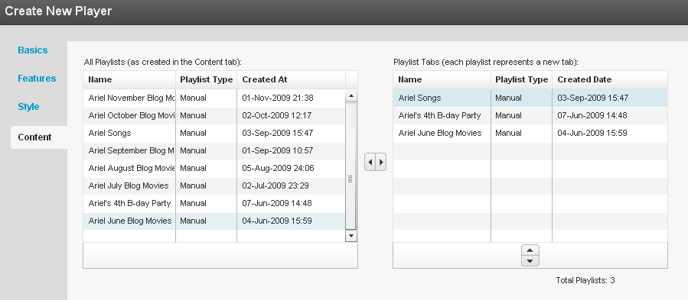  
  
6. The new player will appear in the Players List.

**Users, Roles and Permissions**

* **Managing Users**
  + Adding a New User
  + Removing and Blocking Users
  + Purchasing a License for Additional Users
* **Creating Custom Roles**
* **Changing Your Password (under settings tab)**

**Managing Users**

**Adding a New User**

1. Go to the “Administration” tab and select “Users” from the menu.
2. Click the “Add User” button, and fill in the details in the “Add User” window. Select a role from the “User Role” drop down menu. User roles define permissions granted to the user for the different KMC functionalities.

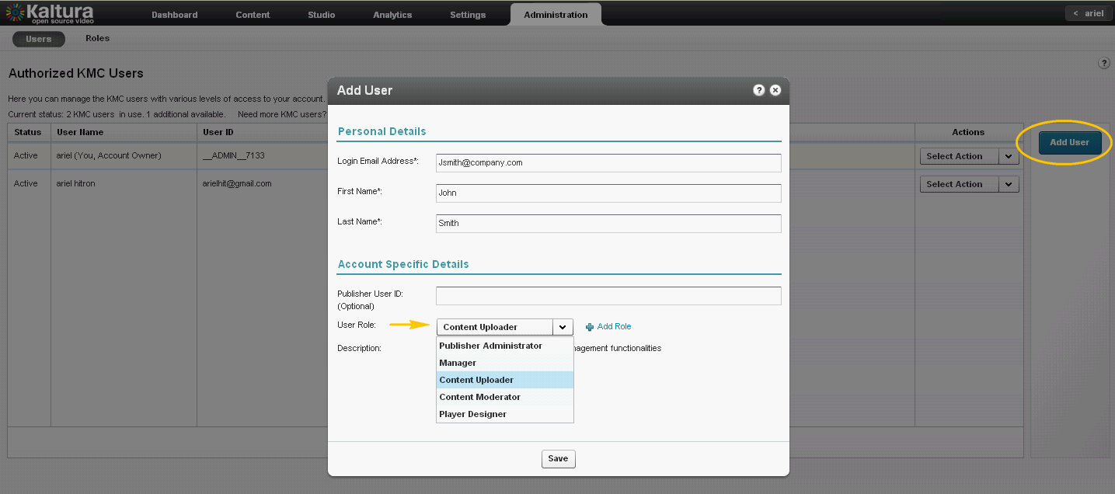3. You can create a custom role by clicking “Add Role”. After naming the role and providing a description you’ll be able to select the specific permissions required. For granular permissions within each category click “Expand All”. See more on Custom Roles in the next section.

4. Click “Submit” to save. Once a new user is created, an email will be sent to the specified email address containing a link to set the account password.

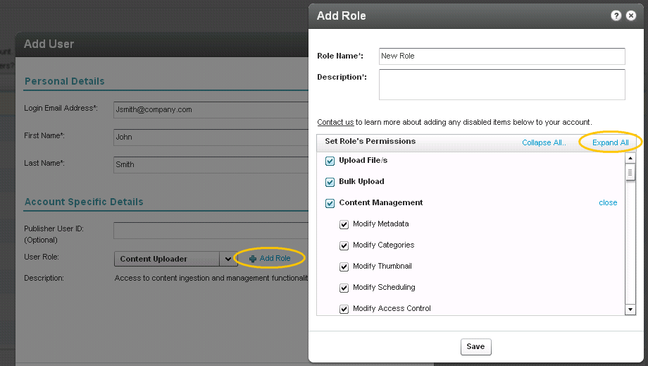

**Removing and Blocking Users**

You can prevent users from logging into the KMC temporarily or permanently by selecting either block/unblock or delete from the “Select Action” drop down menu.

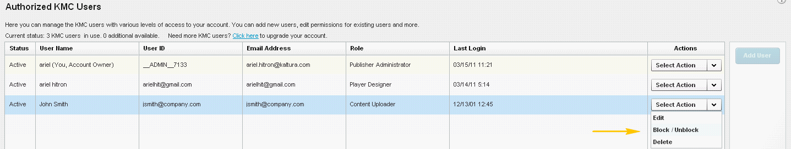

**Purchasing a License for Additional Users**

By default, each KMC account is allocated three users. To request additional users follow the “click here to upgrade your account” link in the “Users” section.

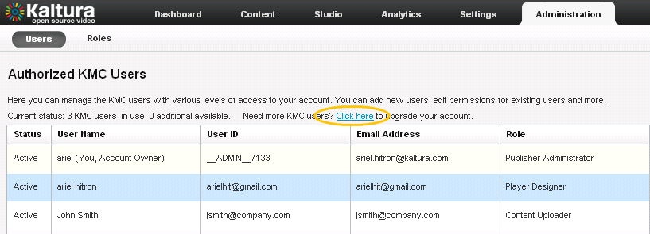

**Creating Custom Roles**

1. Go to the “Administration” tab and select “Roles” from the menu.
2. Click “Add Role”. After naming the role and providing a description you’ll be able to select the specific permissions required. For granular permissions within each category click “Expand All”.
3. You can edit, duplicate or delete any existing role via the “select action” drop down menu.

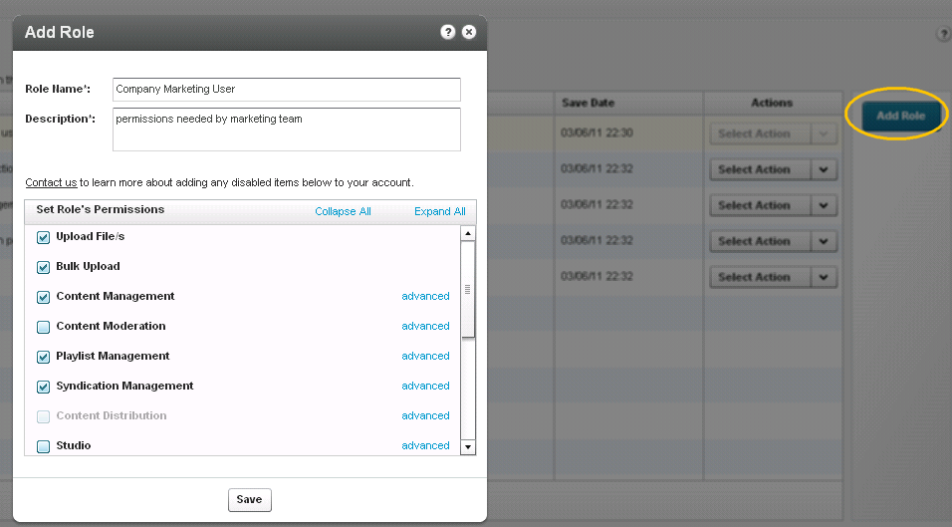

**Changing Your Password**

To change your password go to the “Settings” tab > “My User Settings” and click on the “Change KMC Password” link.

